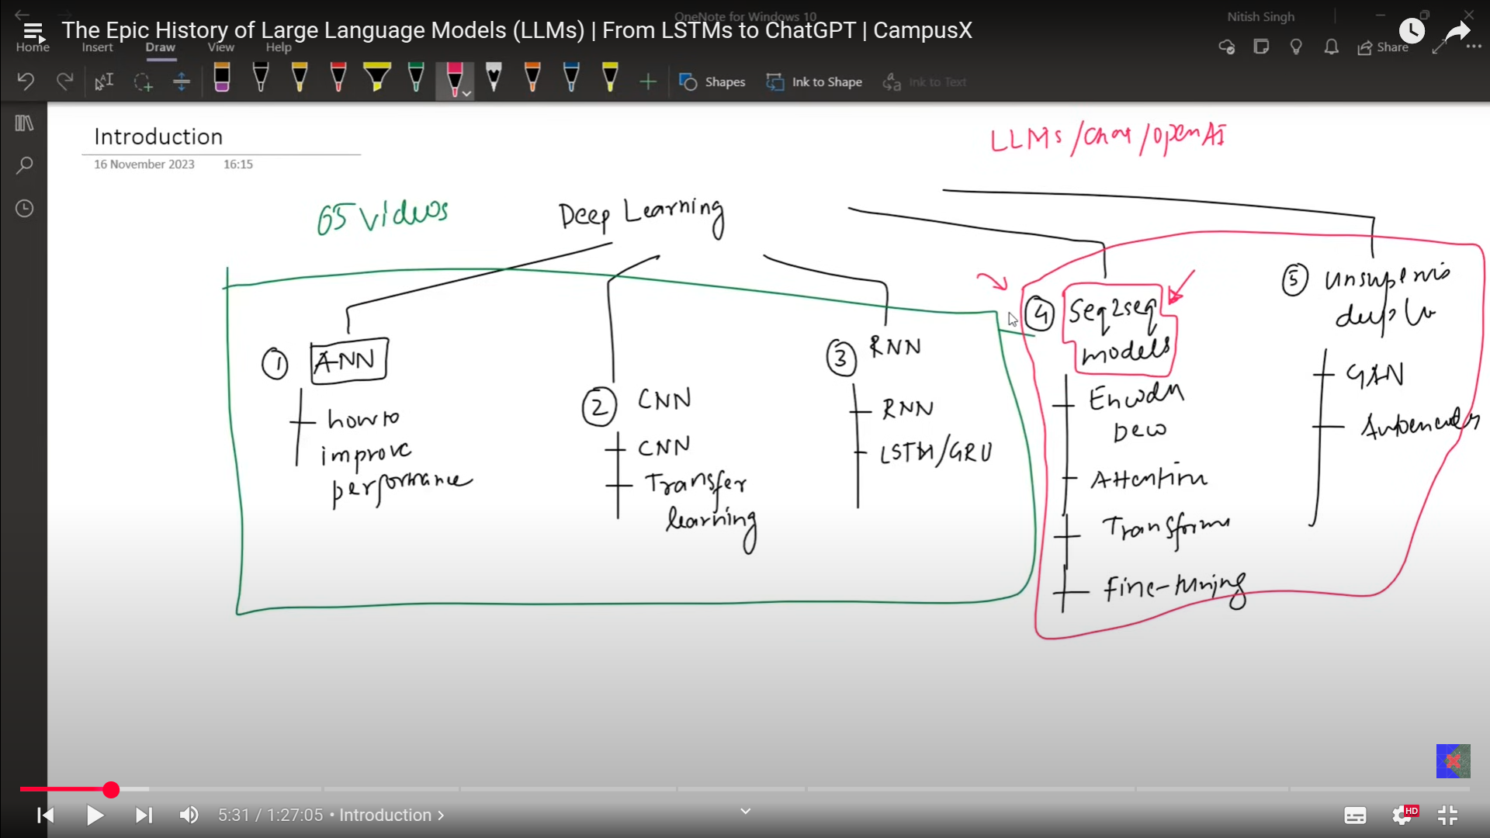
Synchronous and asynchronous RNN describe
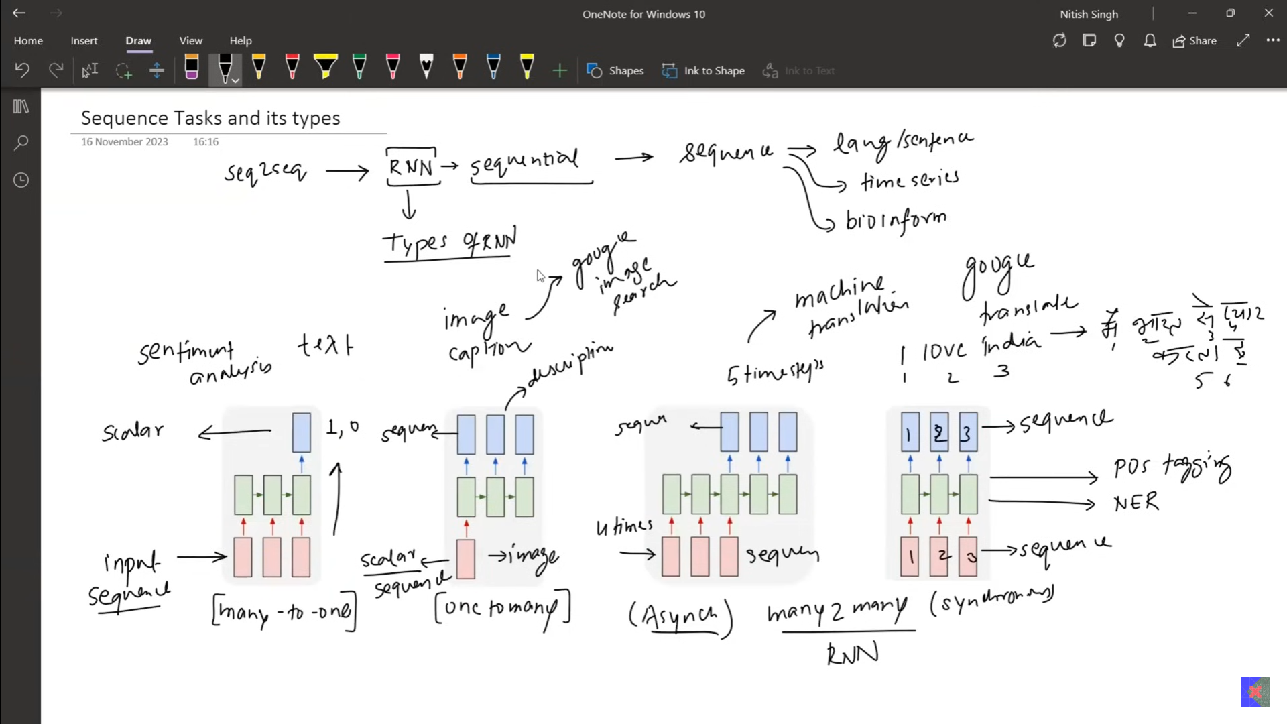
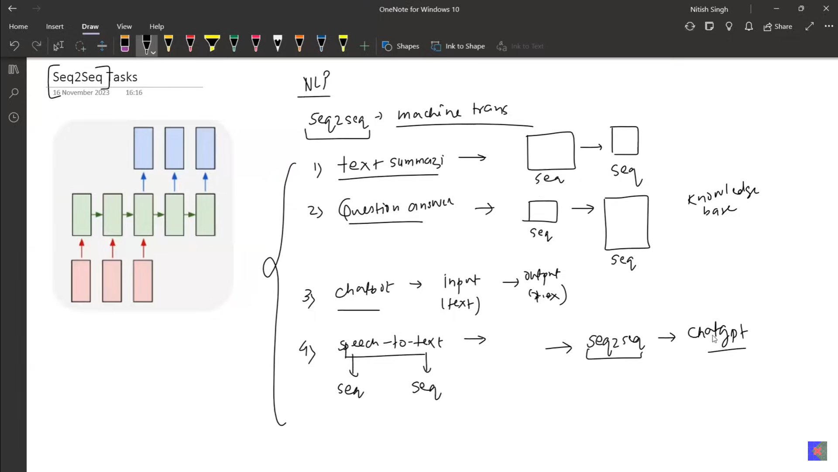
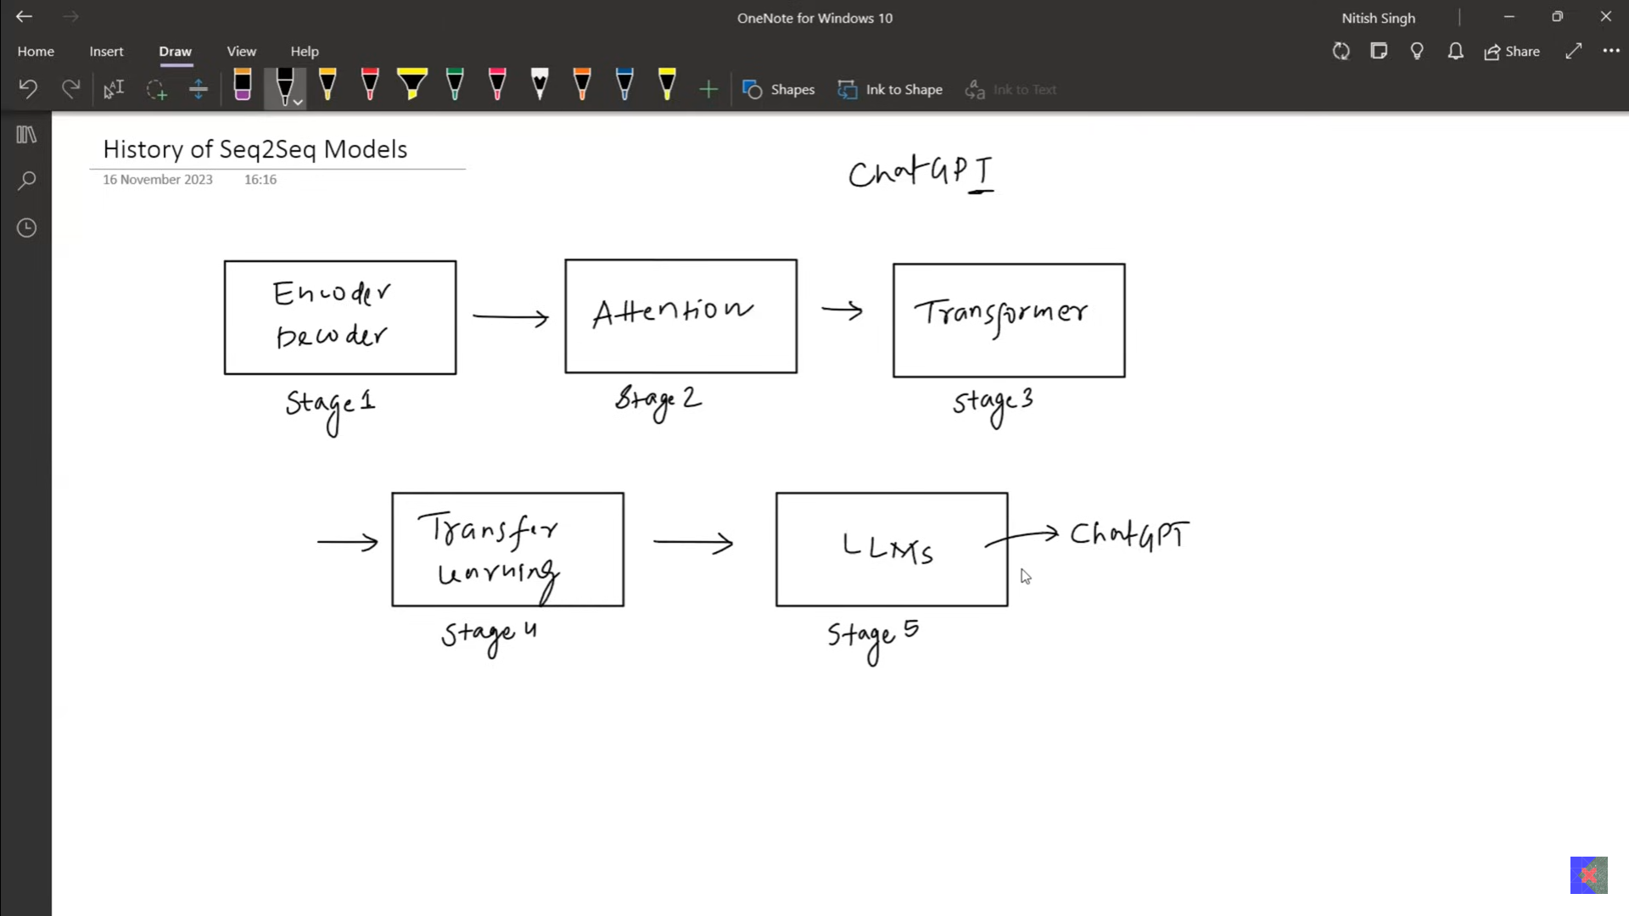
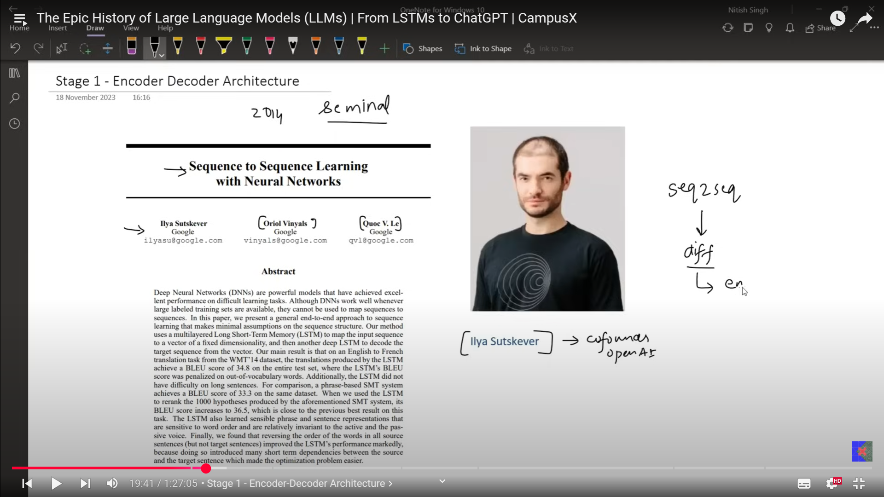
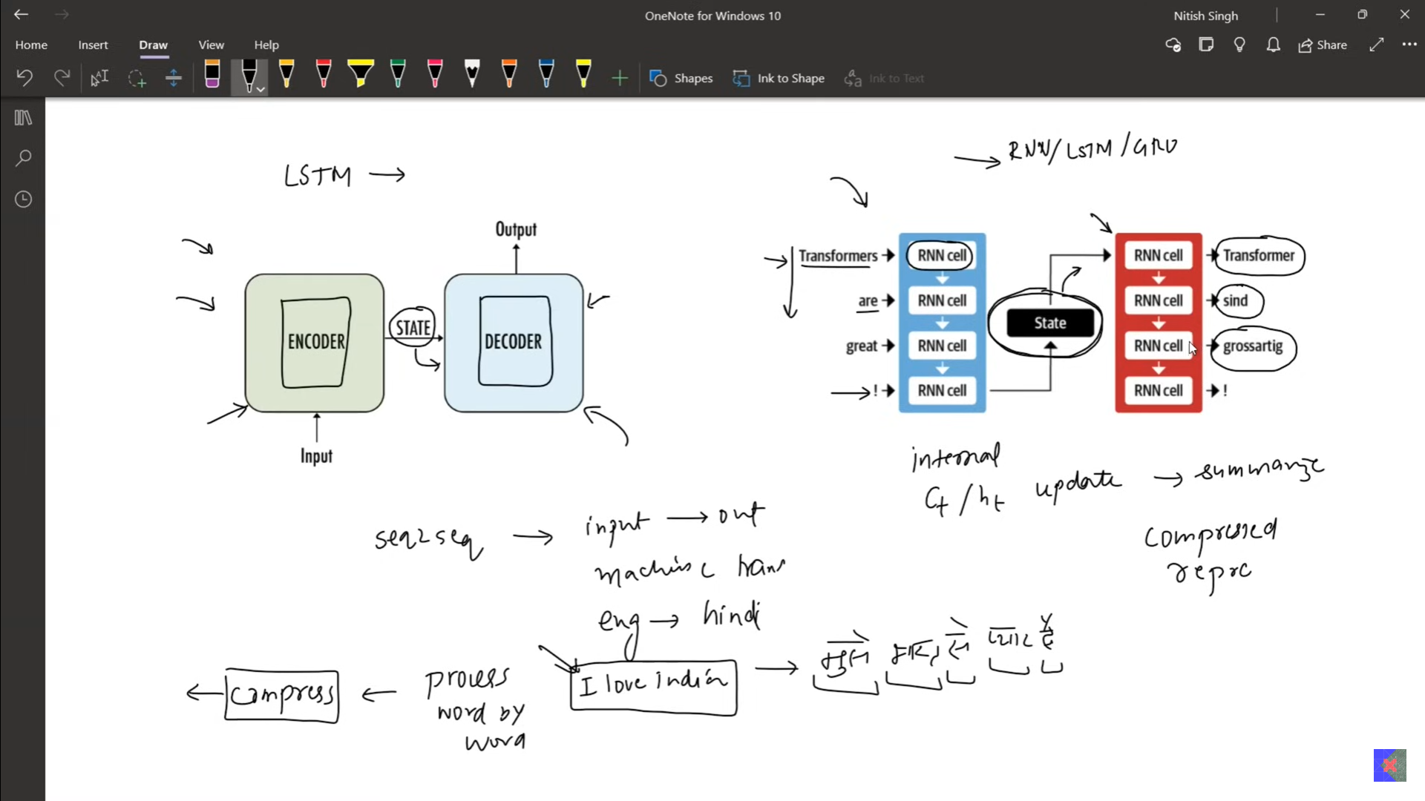
Encoder has LSTM in it. GRU has LSTM in it. When series of information is given as input to encoder, this is used to convert the input to a compressed output state.
This compressed output is taken as input to the decoder and produces the output.

What happened?
When you give the words to the ENCODER(LSTM), each and every word is getting converted to the encoded context vector(State), has the summary of input.
. which is used at decoder.

Problem - with Encoder-decoder:

- Can perform well with the small chunks of data/ input.
2. When small sentences given as input, it was working fine, when it too longer, the output produced by the enc-dec was not correct/ translation is used to lose it meaning.

- The load for context vector representing the whole paragraph was too much, short term memory loss used to happen, so decoding was not happening properly.
- To solve this problem we moved on to the Attention mechanism.
- Input is more than 30 words, then decoder will not work properly.
- 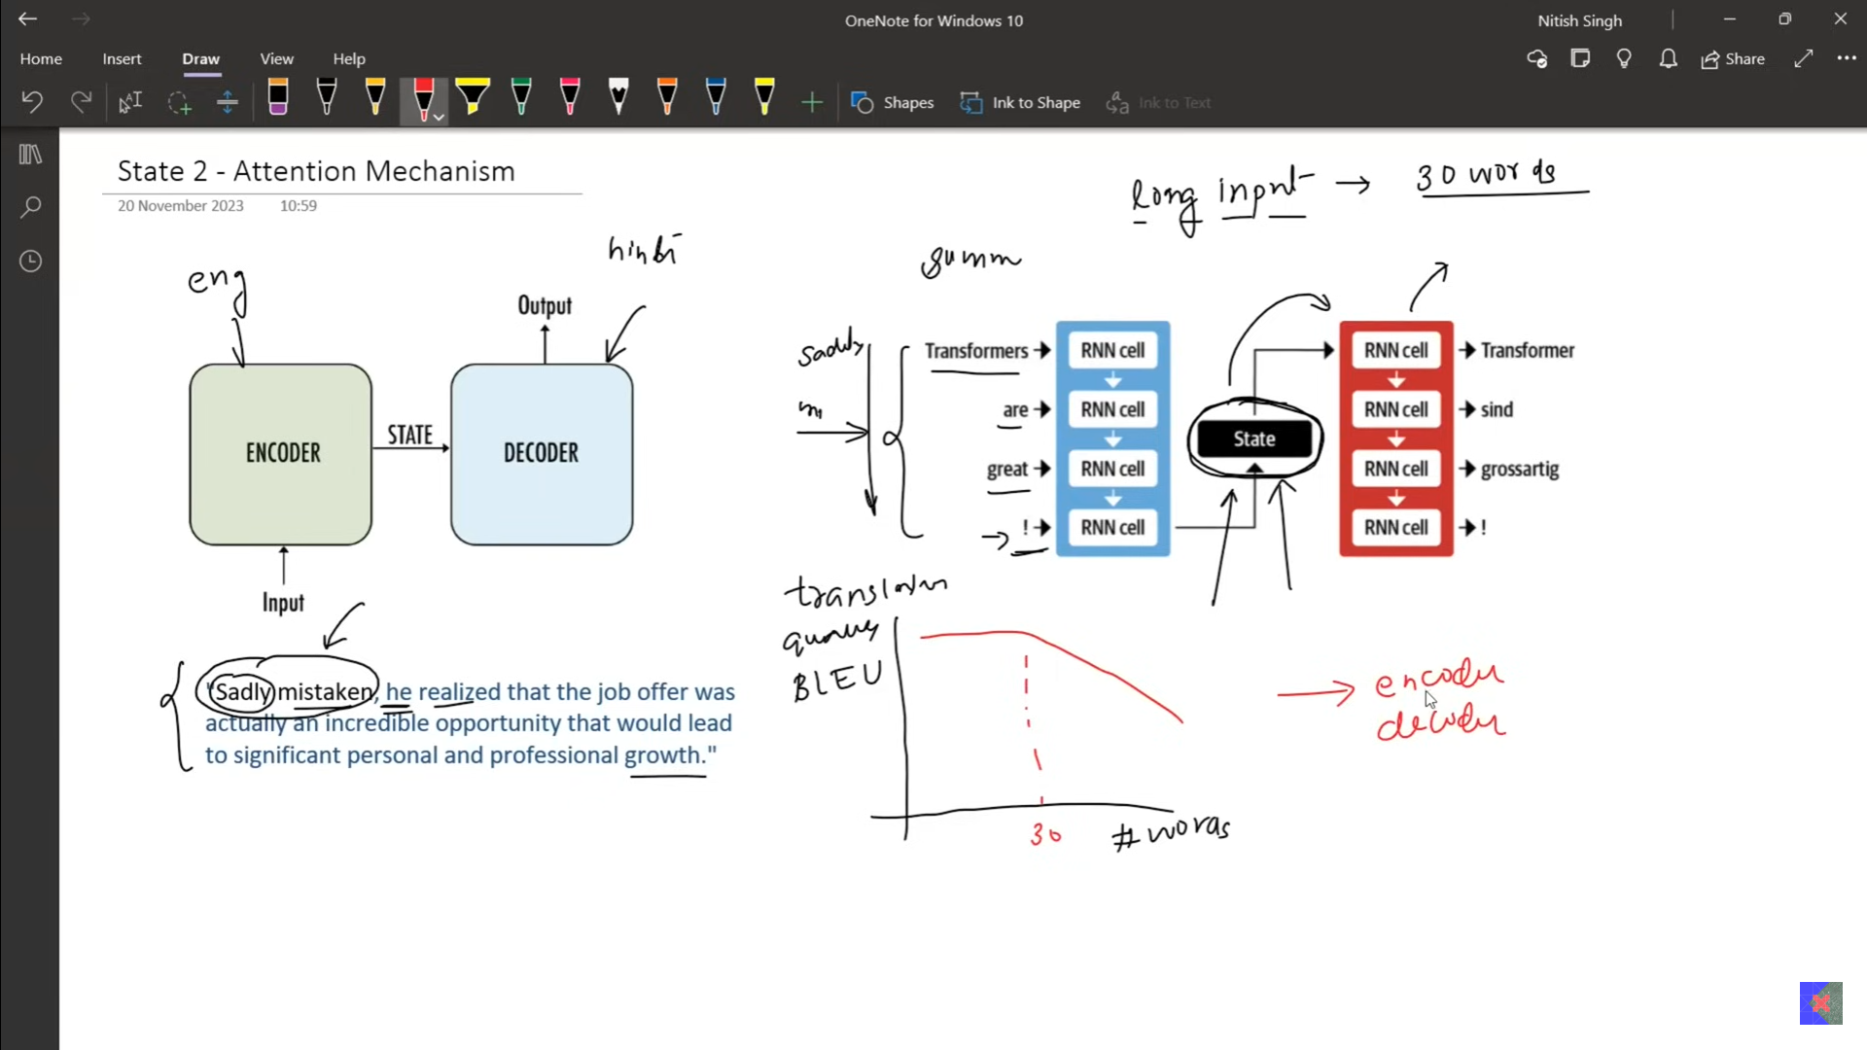
- Above is very imprtant
- Steps:
  - We give series of input, which will be compressed at the state after giving the complete input.
  - The compressed vector representing the whole input’s representation.
  - This compressed vector is used at the decoder side, to preduce the output.
- Problem:
  - Only one state vector.

ATTENTION MECHANISM
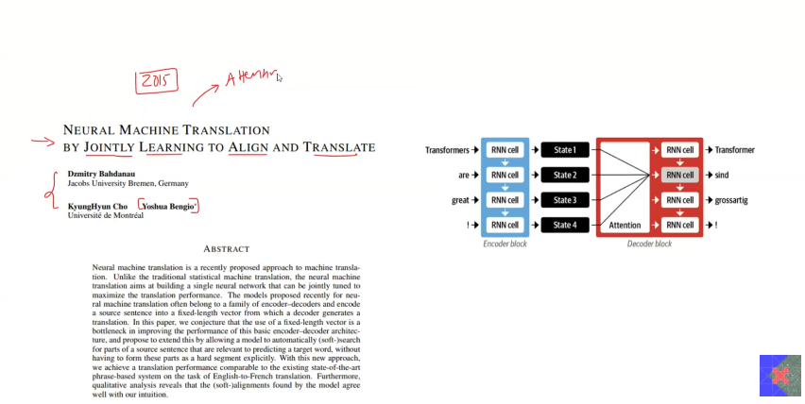

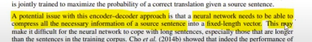
The encoder is same architecture as the older encoder-decoder architecture.
The context vector was only one in previous step, which has to capture the meaning of the whole sentence.

Steps:
- Encoder keeps producing the output in terms of context vector at each time step.
- The context vector at each step is used for the sake of producing the output.
- decoder: To produce the output at any time, we have the context vector of all time units.

Problem
- To produce the output we have the too much of context, which context to choose is the question.
- To print the word, we have the context of whole sentence.
- So print the output which hidden layer to choose is the question.
- To remove this problem there comes a mechanism called Attention mechanism, which is used to capture the which context or hidden layer shall be used to print the output.
- 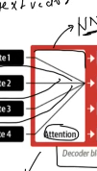 This white picture is attention mechanism, which has the nueral network which decides which hidden layer from the encoder to be used at the current step in order to produce the output at the decoder. This is called the attention mechanism.
- Attention mechanism:
    - It is the nueral network which has all the information regarding the input context based on the input time stamp, when there is need to produce the output, it will decide which hidden layer shall be used to produce the output.
- 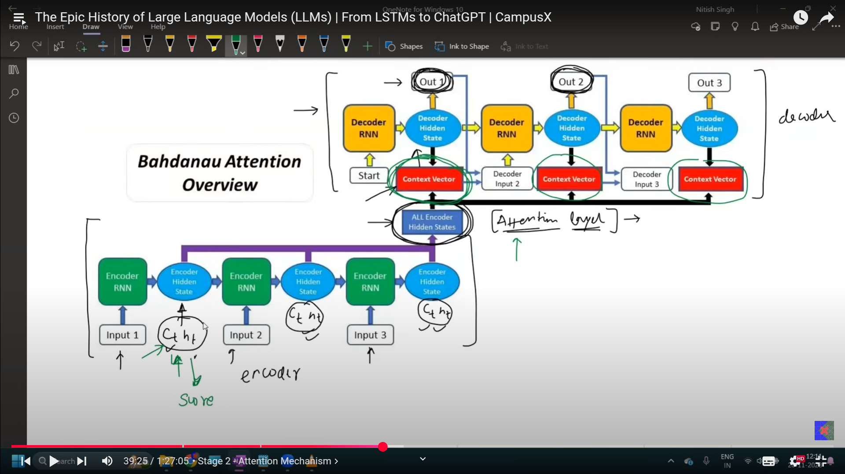
    - We calculate encoder network.
    - All the hidden layer of encoder are available at the ALL encoder hidden state.
    - When need to produce the output, through the decoder, all the hidden layer from the encoder, kept in attention mechanism. This attention mechnaism decides which hidden layer to choose at the decoder to produce the output.
    - At each time step at the decoder we are calculating the different context vector. This increases the computational complexity.
    - Overall, at output at the decoder at the current time stamp, checks for the which are all the input states matches with the highest similarity, that is choosen to produce the output.

  - Computational complexity
    - So need to calculate the similairty with all the words.
    - This generates the quedratic time complexity.
    - The problem with this kind of architecture is LSTM, which process the input sequentially, this sequential processing has to be replaced with the Parallel processing, This is where the transformers come into picture.

- Transformers[ATTENTION ALL YOU NEED].
    - Takes the input in parallelly rather than sequental input, which reduces the complexity in terms of time.
    - 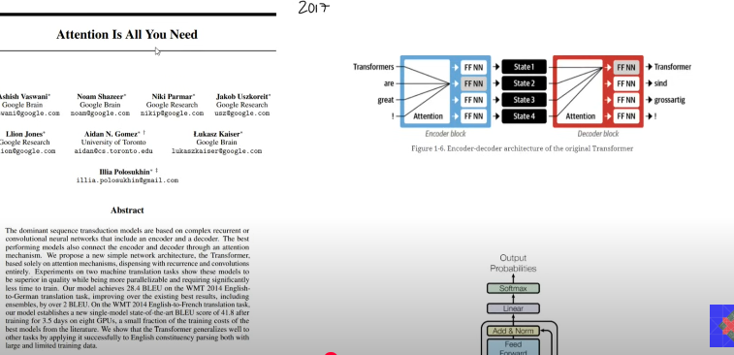
    - 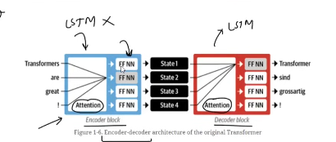
    - In transformers the LSTMs were removed and replaced with the attention at both the ends.
    - Then comes the Fully connected Feed forward layers.
    - 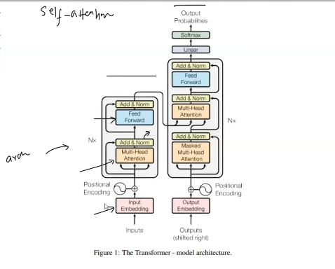
    - Changed the picture of the NLP.
    - 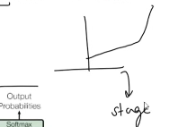
    - Disadvantage of transformers
      - 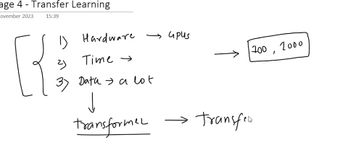

Transfer Learning[ULMFiT]
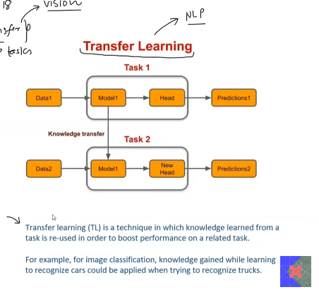
Task1:General learning
General way for building the model, which learns and generalises based on what it is learned. Normal CNN or any model buidling.

Task2: Fine tuning
Based on the pre-built model, a new head is attached along with the data of our own wish. This makes the prediction. This altercation with the model is nothing but fine tuning.
EX: Image-net(dataset): Contains millions of image set of different category. We use one of the pre defined model then based on it we pass the data to the model, hence making it train for new labels, which capturing the predefined information making it to work for new attached labels.

In NLP, transfer learning is not that helpful till this paper was established, because:[ULMFit]
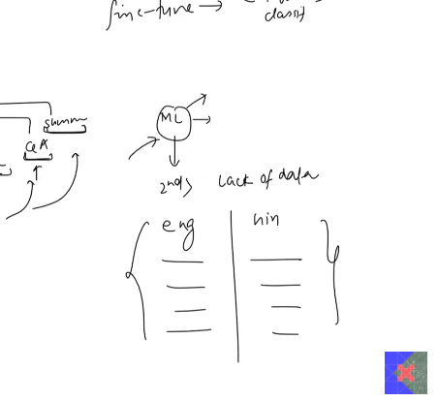
Till it is 2018, Transfer learning is not possible in NLP
- Task specificity:
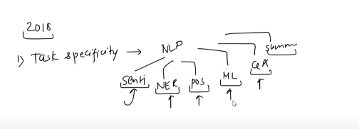
- Problem 1 : Each and every task is totally different. Requirement needed was totally different from one another.
So generalising the model was not possible till 2018.
- Problem 2 : Lack of data. Needed hell lot of data.
  - Solution :
    - Language Modeling: NLP task, deep learning model which is used for next word prediction.
      - This language modeling was used as the pretrained model.

- 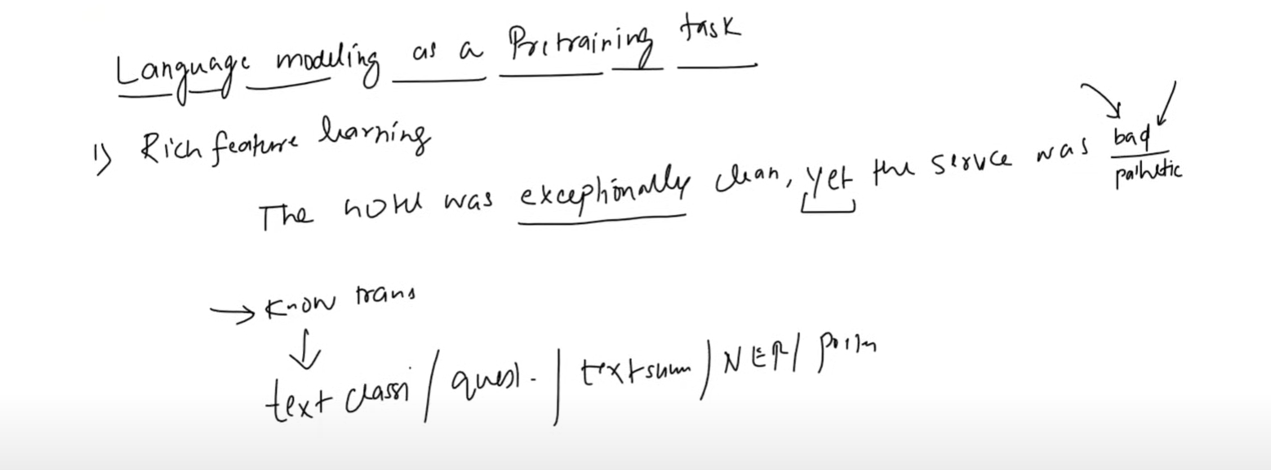
  - In rich feature learning, the model not only learns about grammar, it learns about semantics , sentence structure, and also the language.
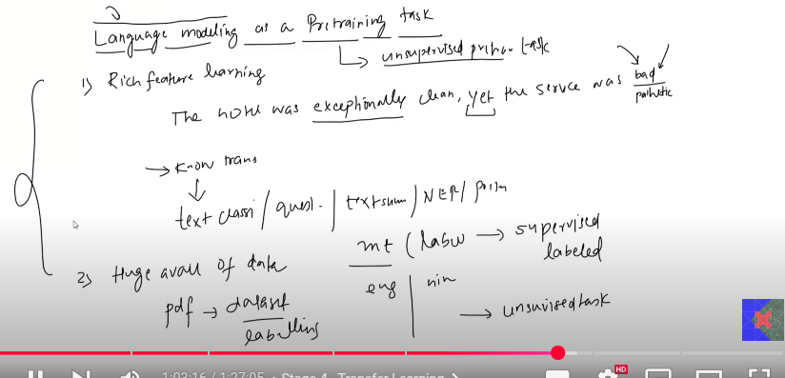
When you use the language modeling as the training task, there is no need for labeling data. We get enormous amount of data.
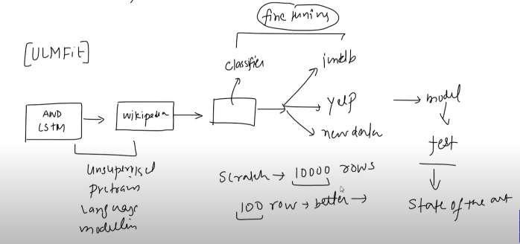
The language modeling is used as the primary concept here in this paper. First it is trained using the wikipedia dataset.
Once this is done , the fine tuning of the model is made at the last layers of the which is later tested for accuracy, different dataset, later gave greater accuracy.

They reached the accuracy, which was unpredictable. If anybody is building the model and was able to get the accuracy for 10k rows therse wee able to get the output for 100 rows dataset. This is was obtained from the finetuning of the model.
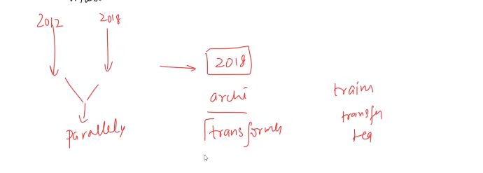
They did not use transformer.
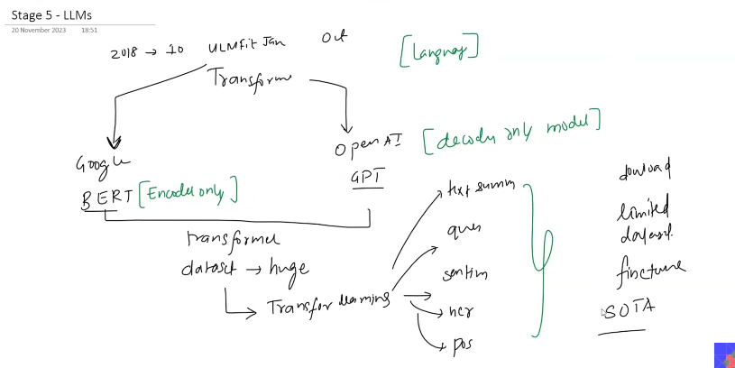
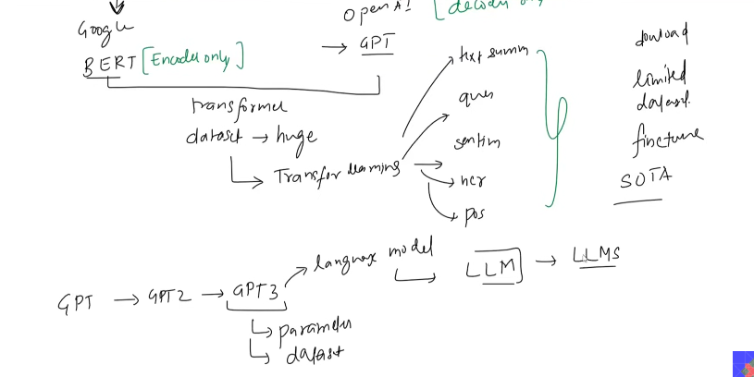
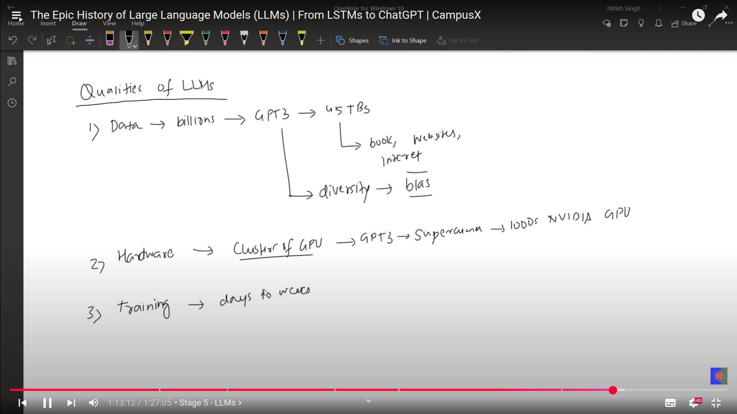
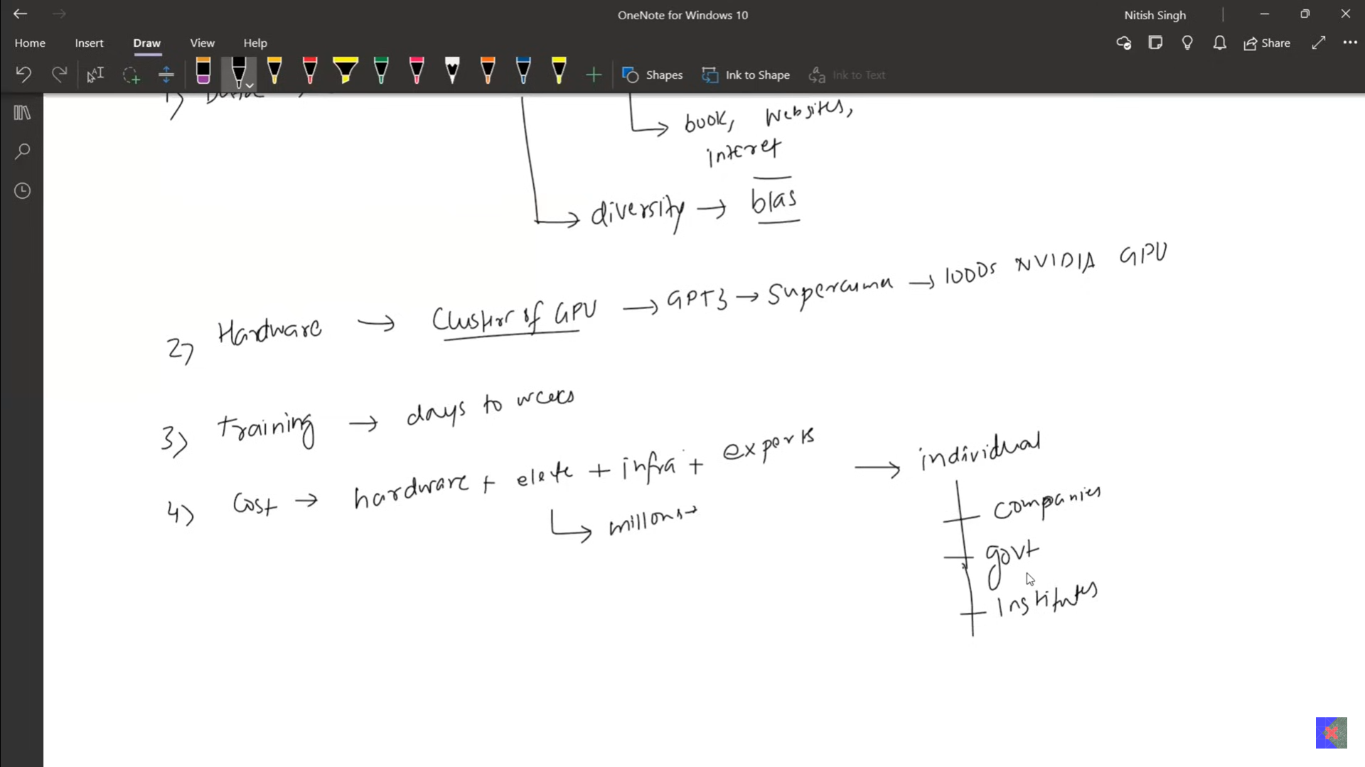
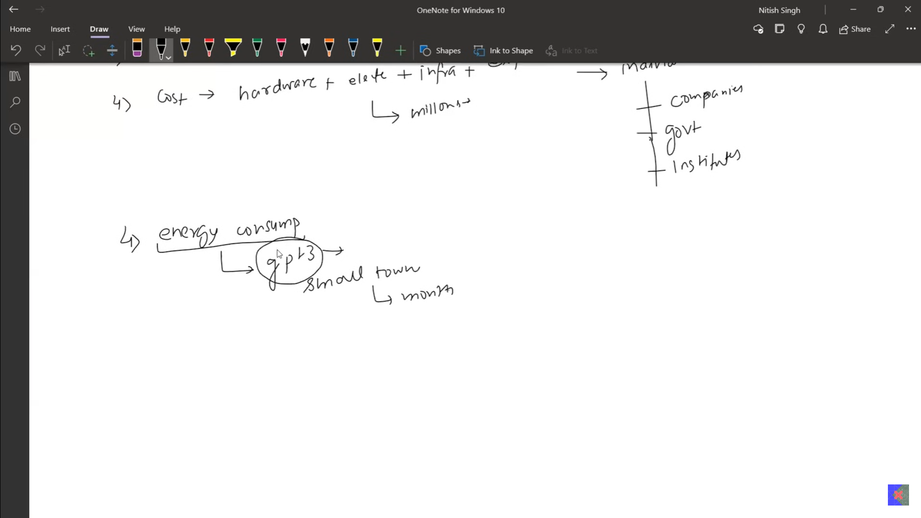
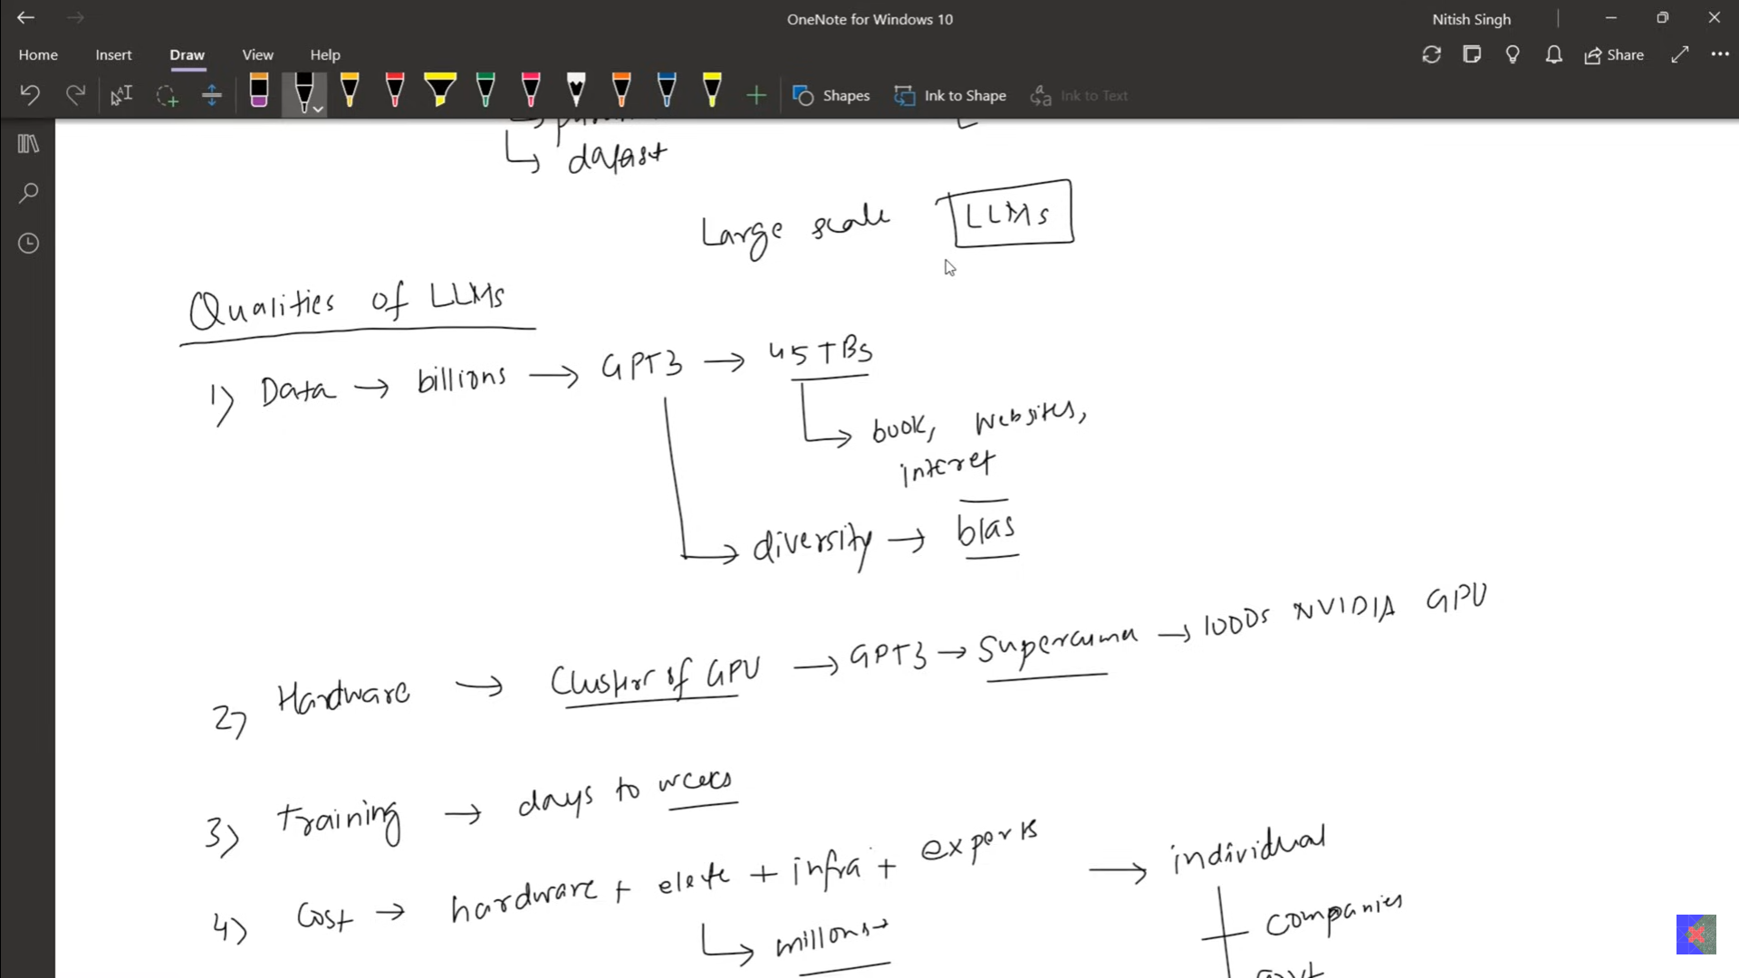
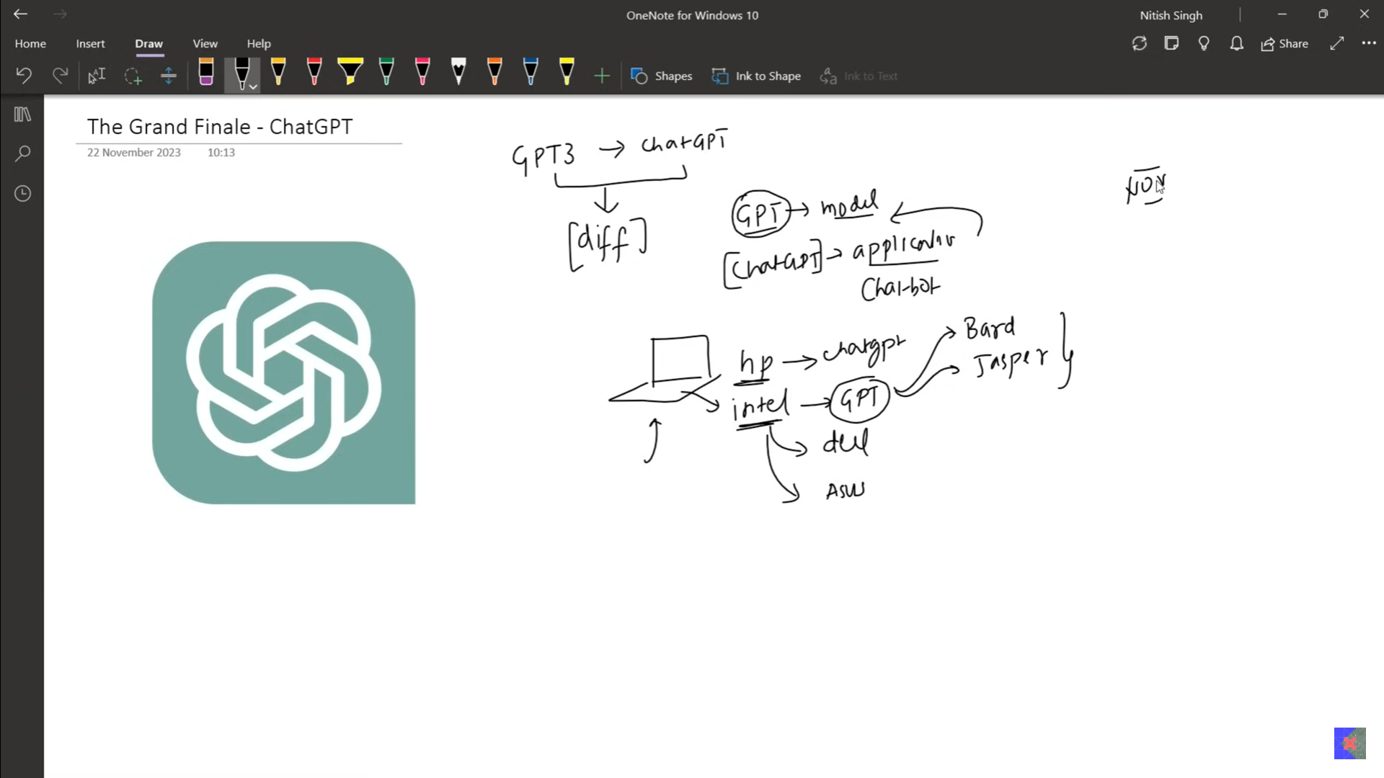
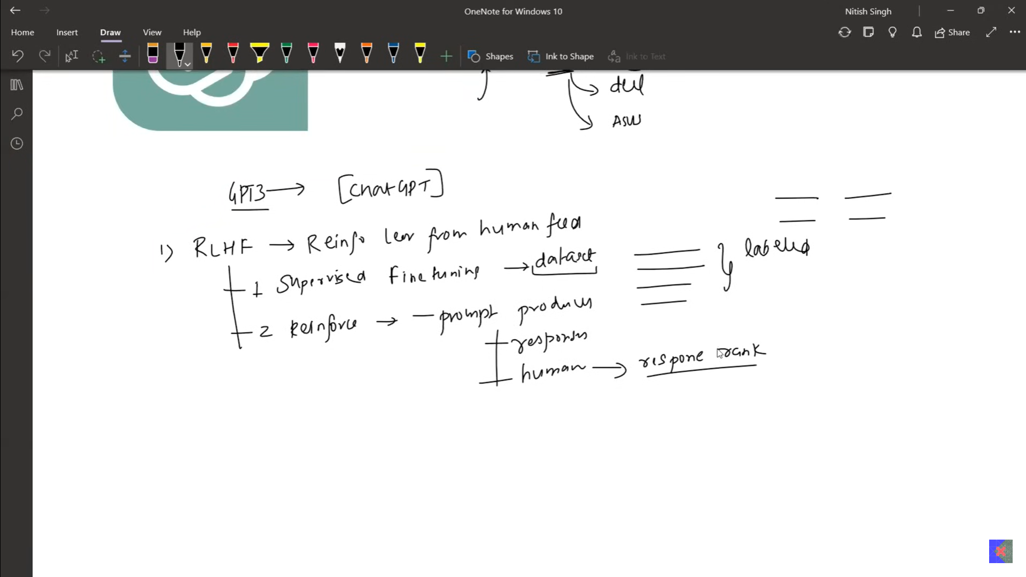
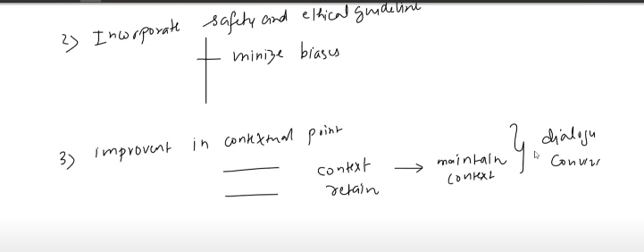
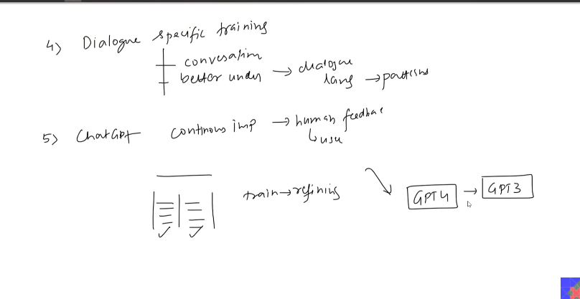

- The primary task in ULMFit - data Modeling is used.

- ENCODER - DECODER, SEQUNCE TO SEQUENCE
  - 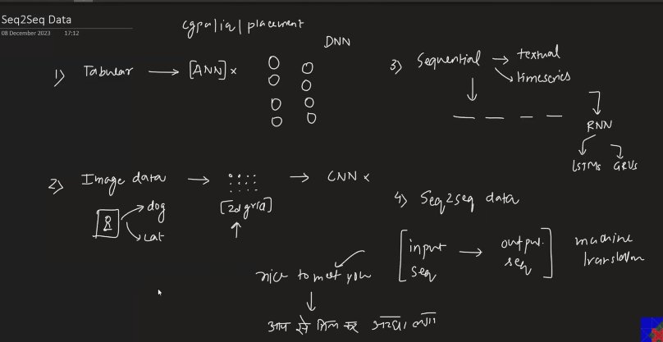
  - Challenges to sequnce to sequence models:
    - 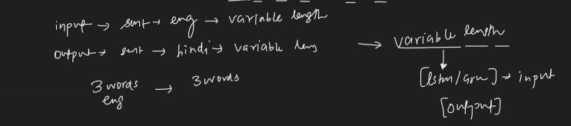
    - The variable length input handling was possible by the help of LSTM and GRU, but it was not possible to handle the variable length output.
    - 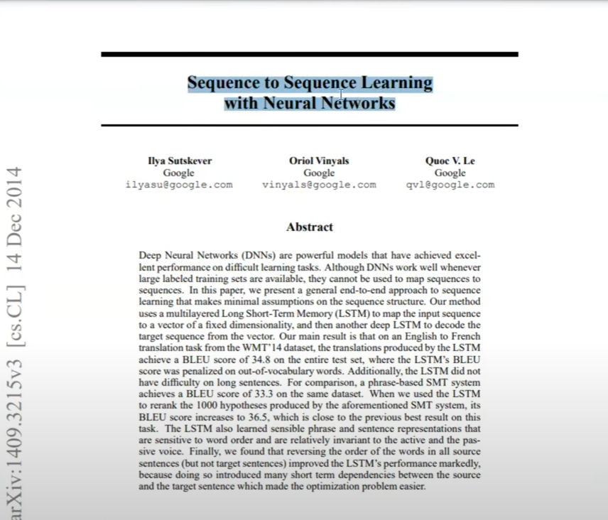
    - 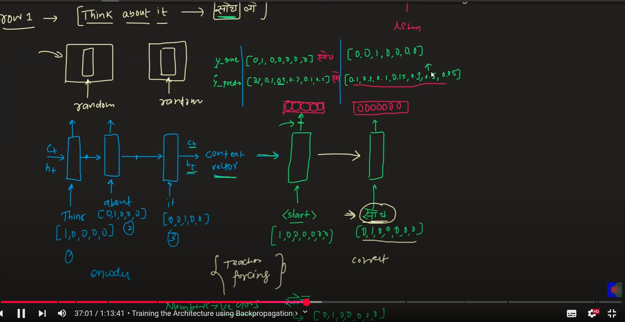
    - 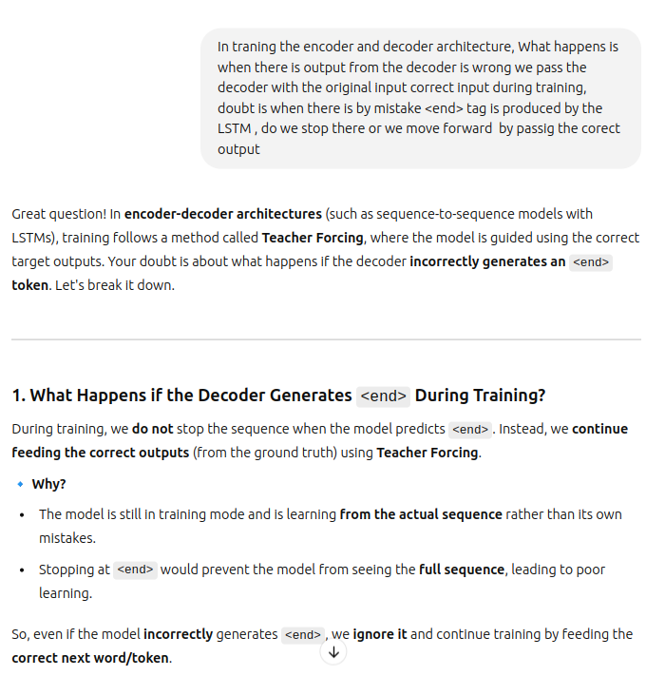
    - 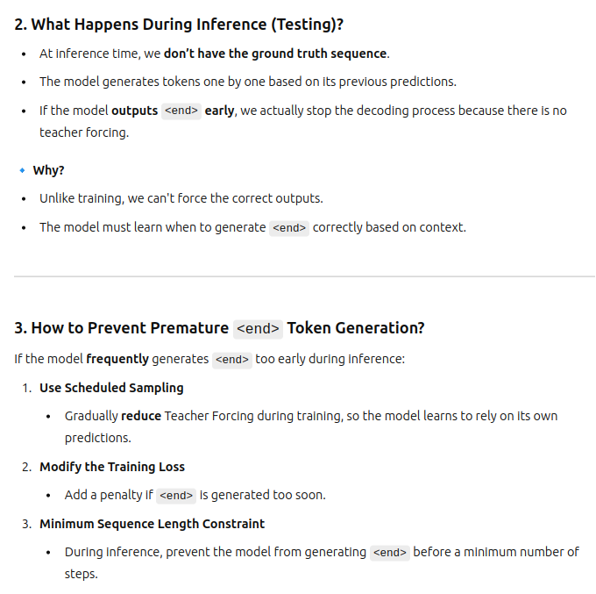

    - 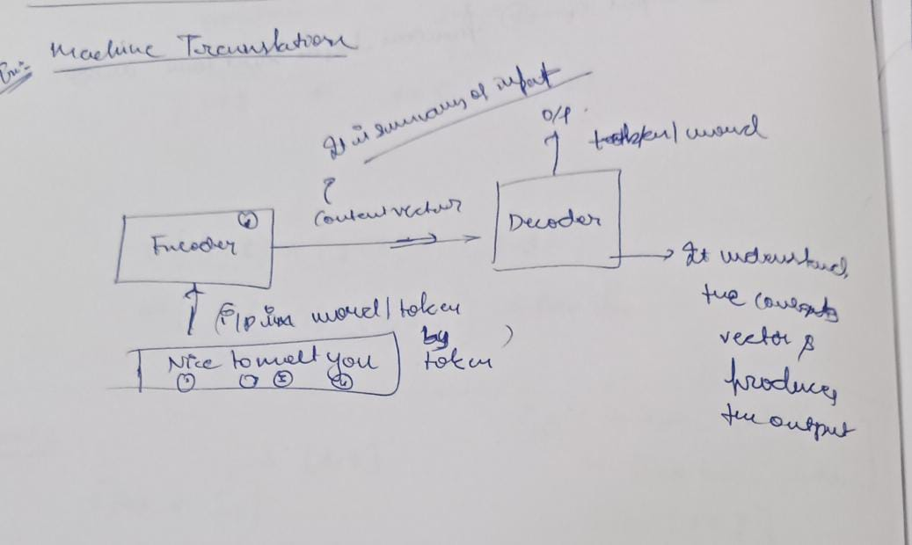
    - 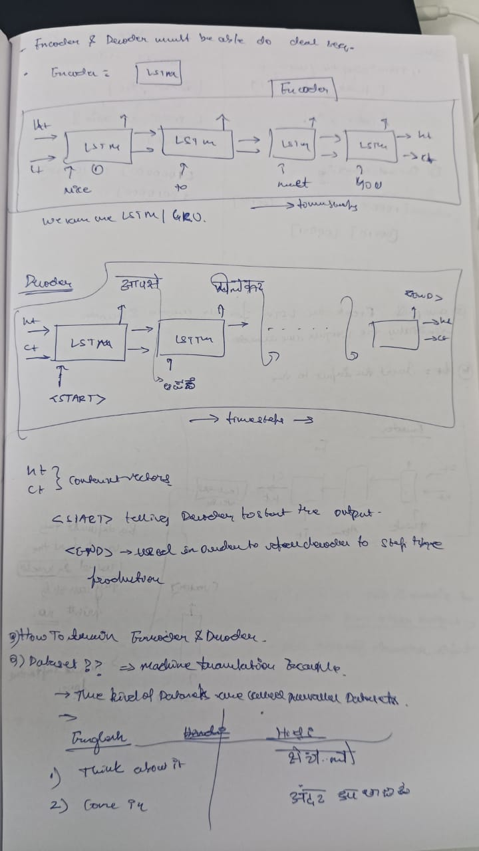
    - 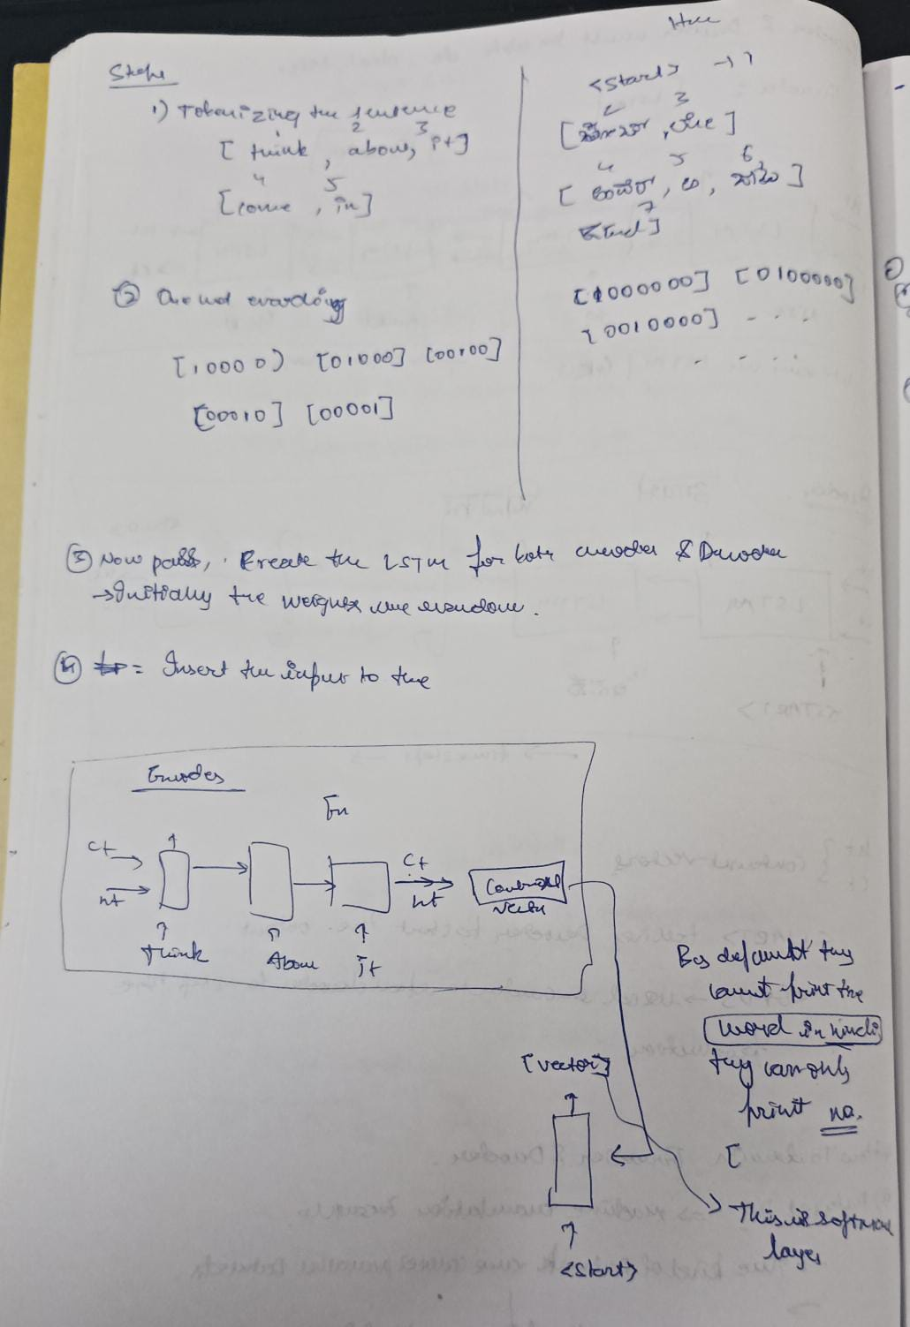
    - 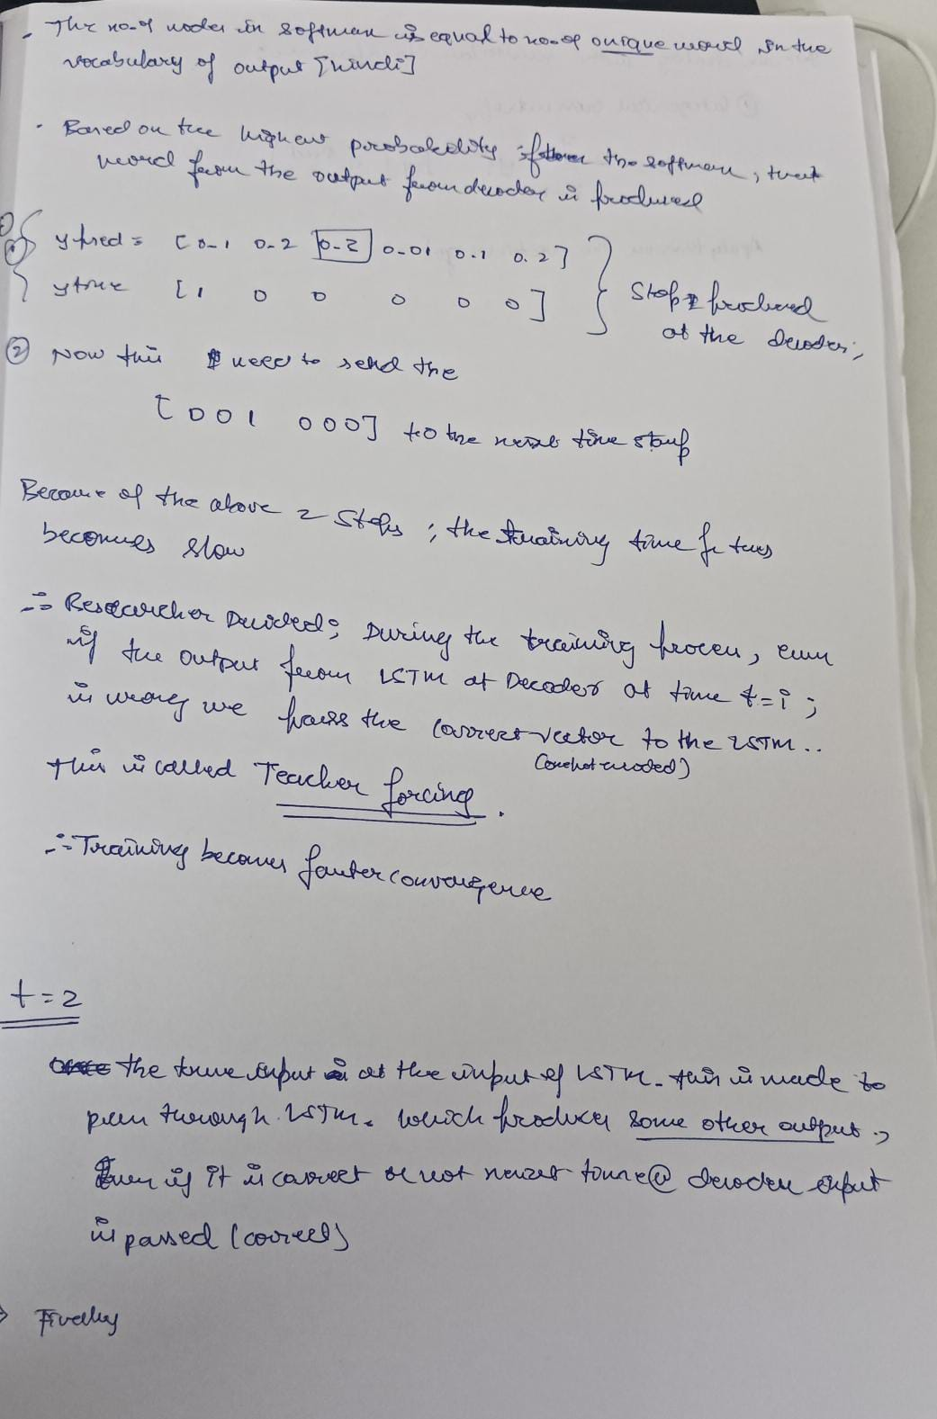
    - 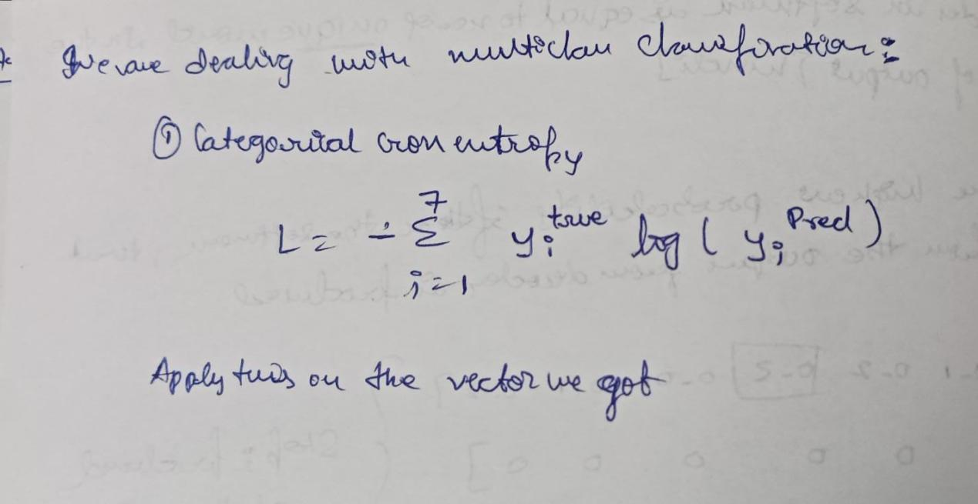
    - 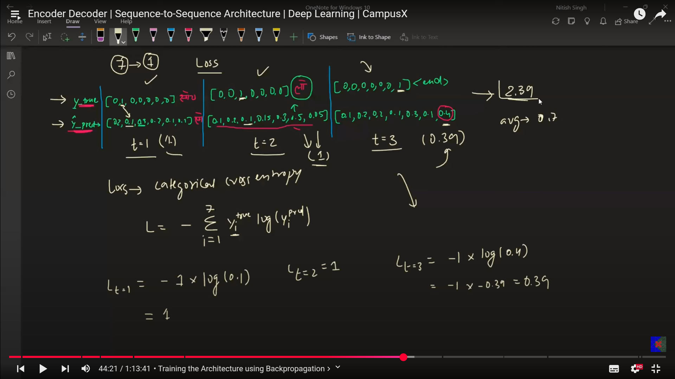
    - The one which produces the correct output will have less error compared to others.

In the previous steps we have been through the forward propagation, and loss then now it is time for backward propagation.

- Backpropagation:
  - Gradients calculation - Calculate the gardient of the loss with each of the trainable parameters. On the basis of these gradients. We update the weights.
  - Update the weights using some optimizers like SGD, ADAM, that will decide the
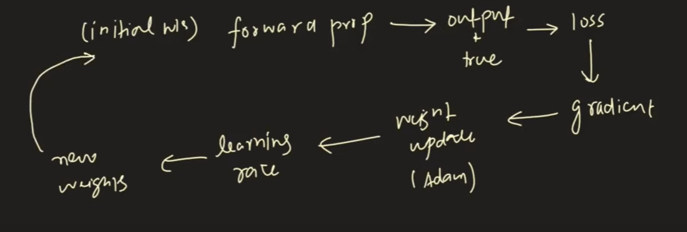
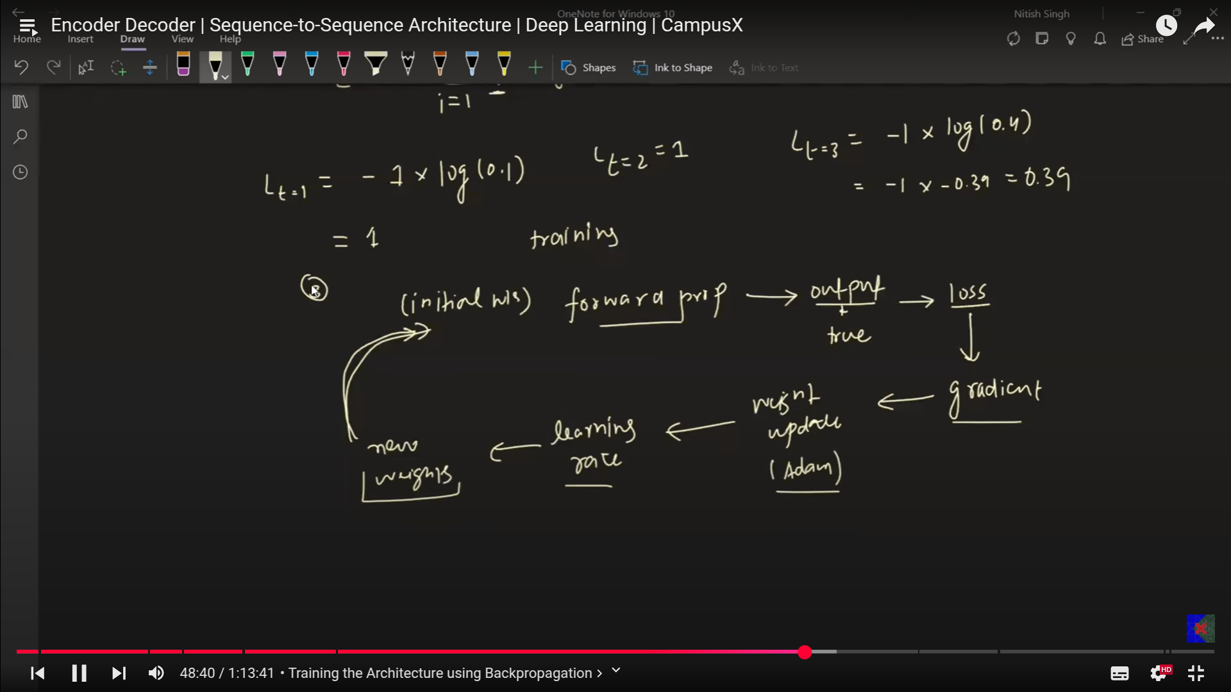
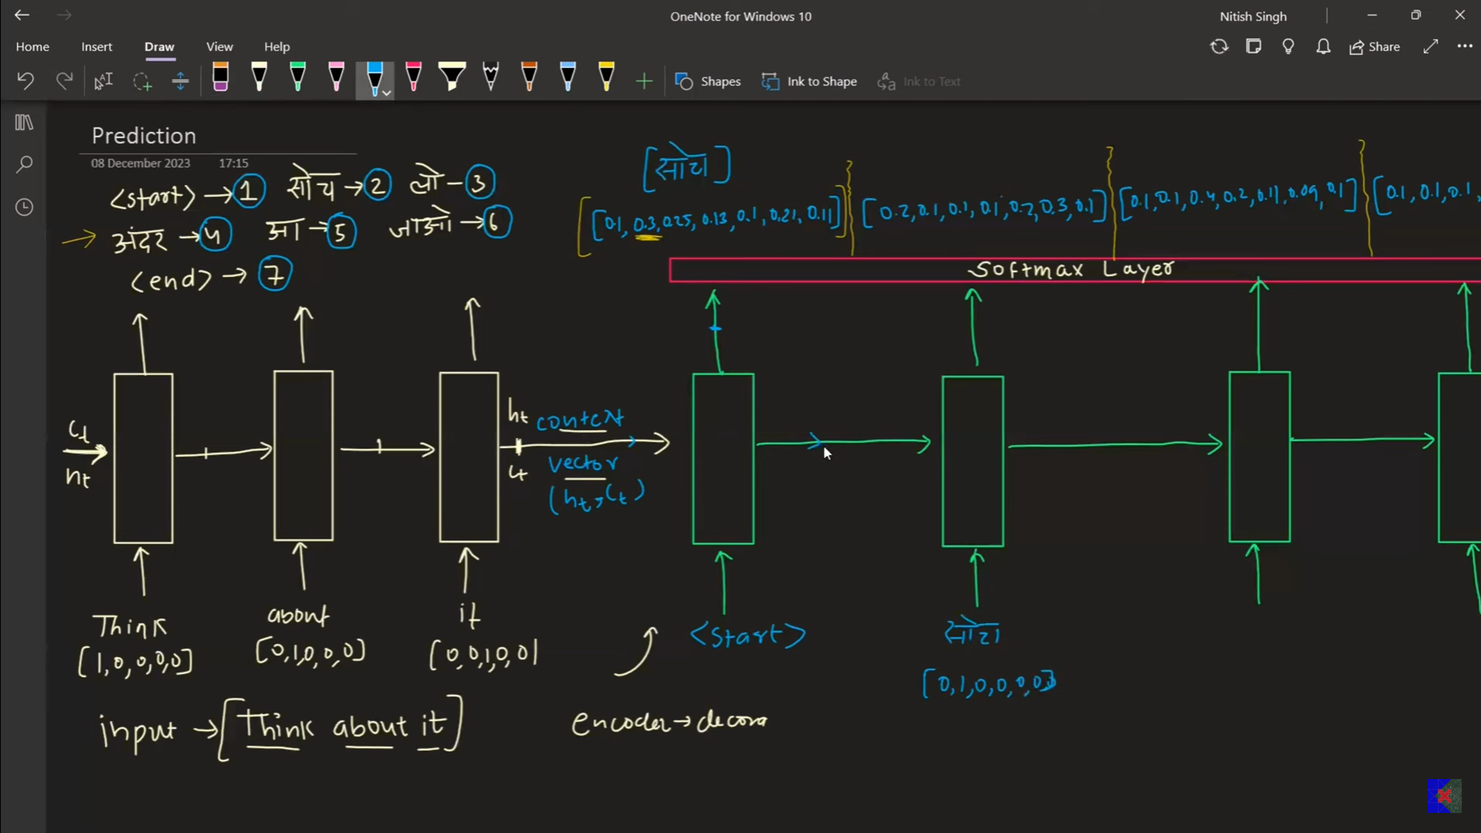
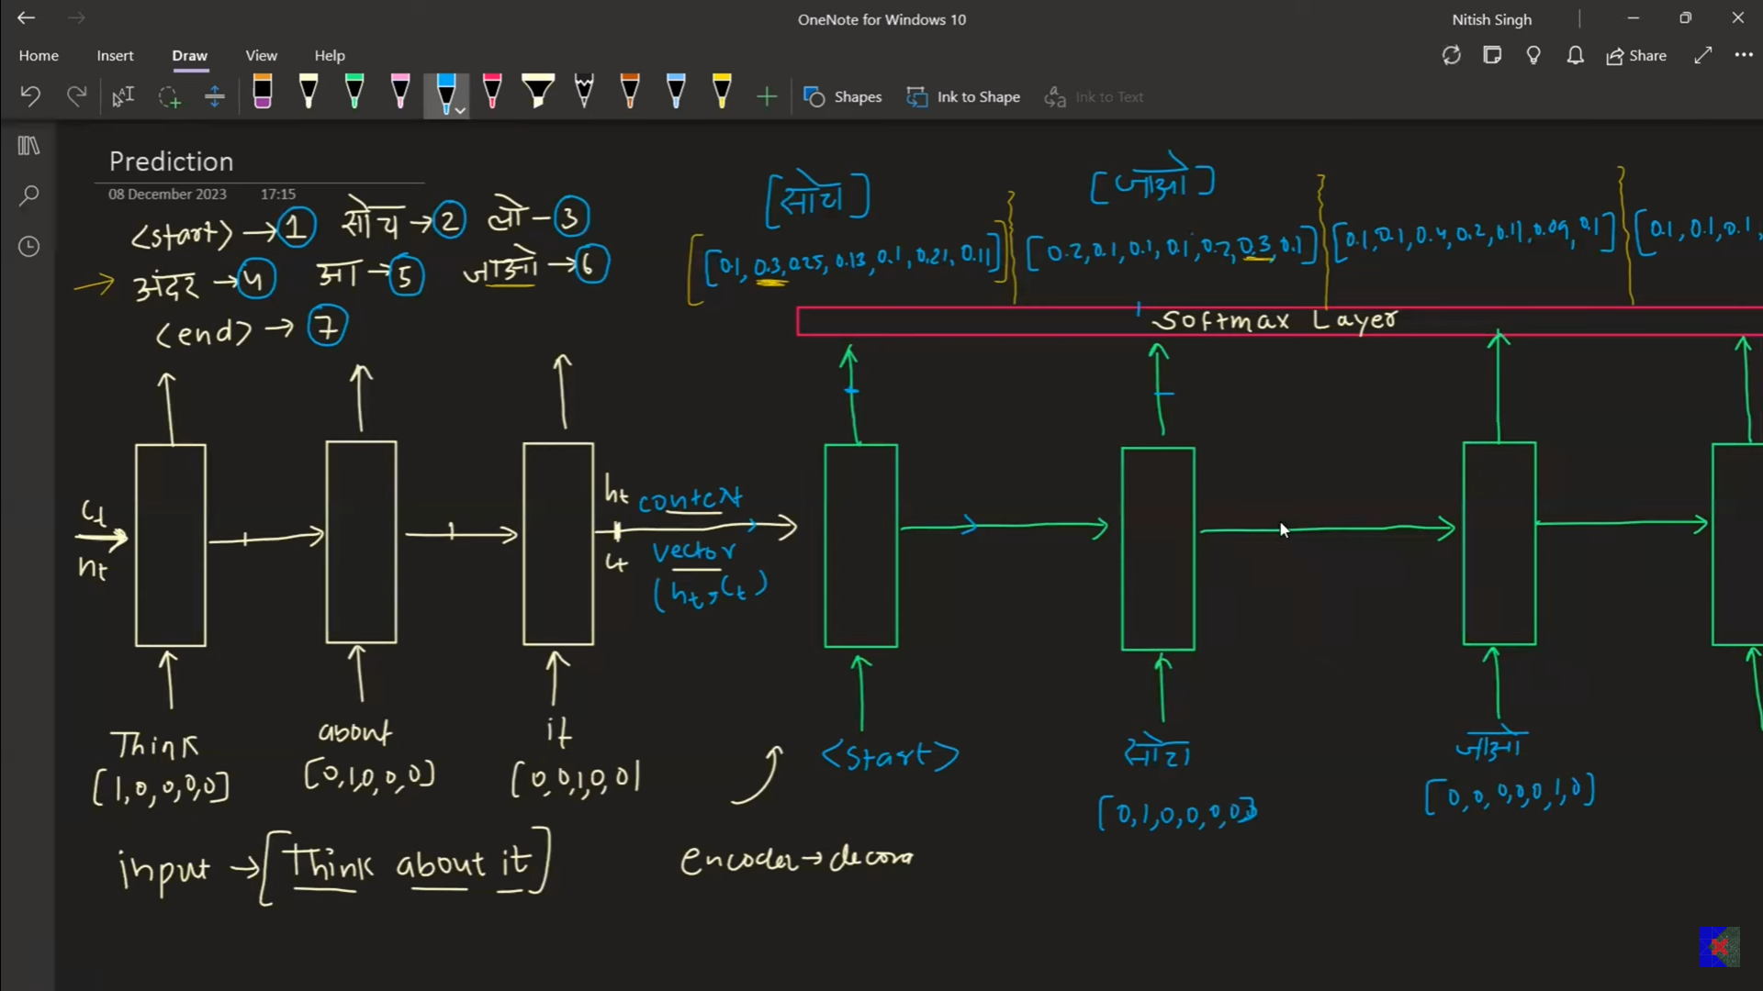
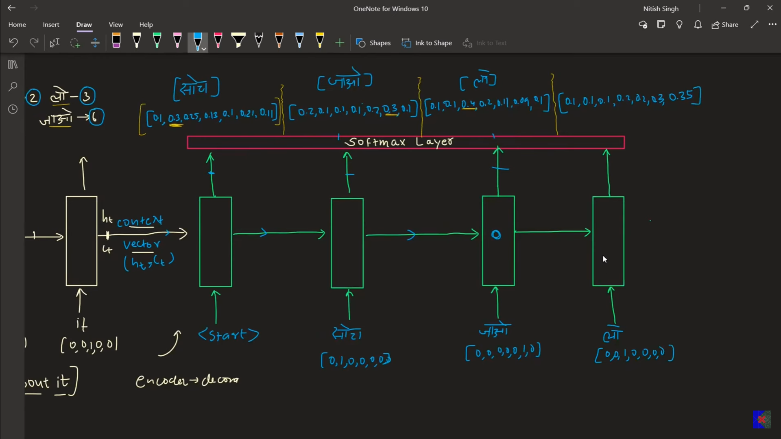
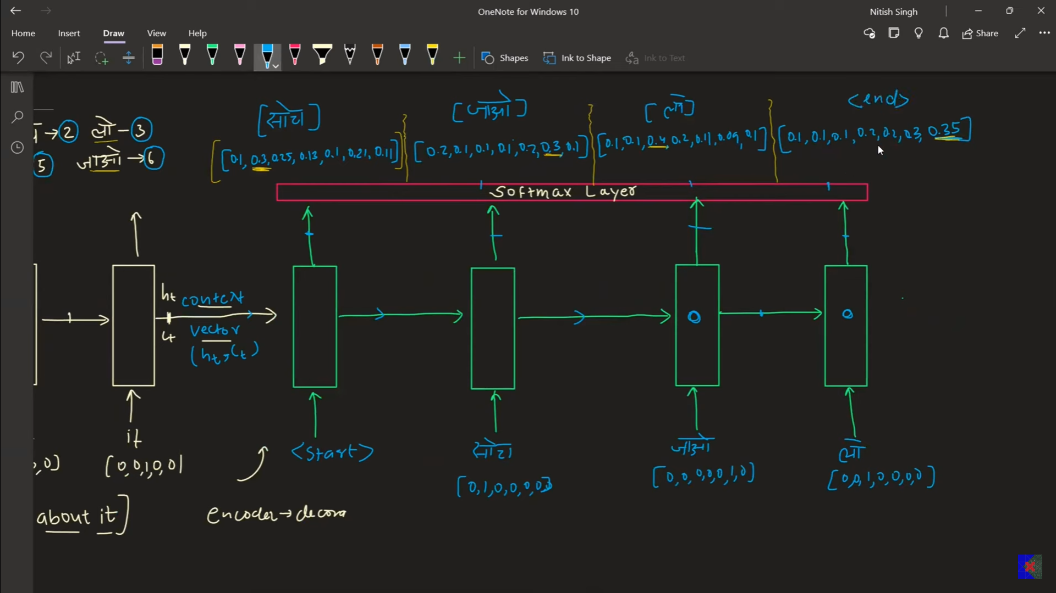
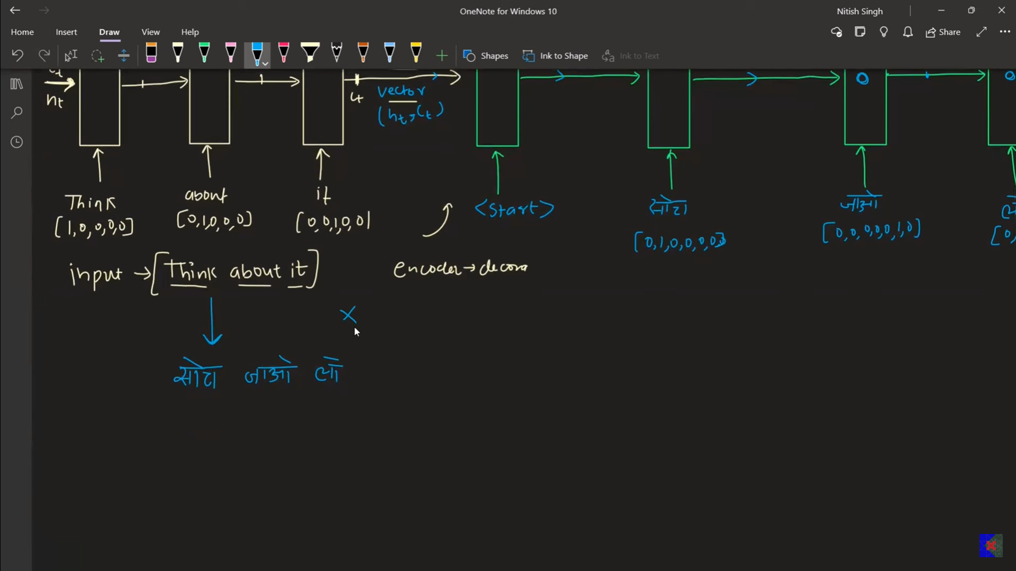

Improvements of the LSTMs

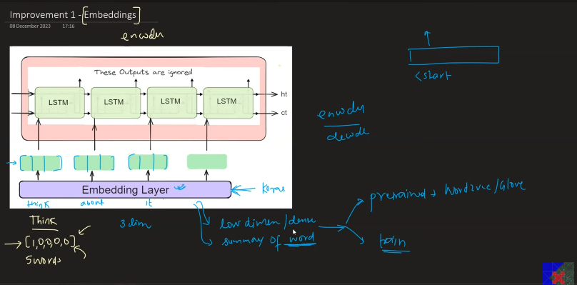
Embedings will give the low dimensional dense representation of the word whihc captures the context of the word.
That is why we use the emebeding layers for buth the encoder and decoder.
Pretrained embedings, dynamically made embedings. In research papers we use the embedings.
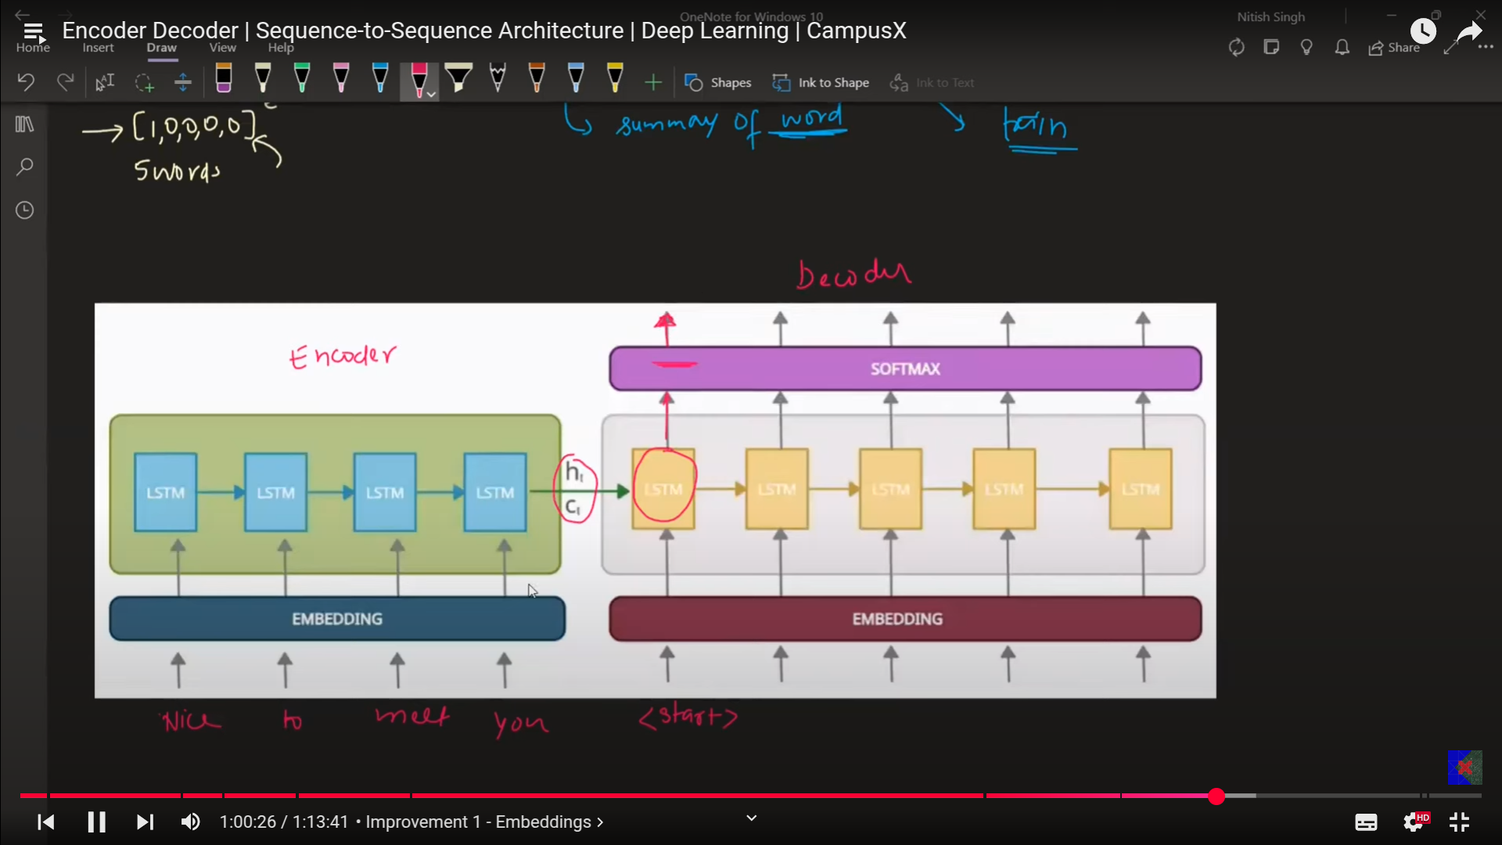

- Deep LSTMs

  - 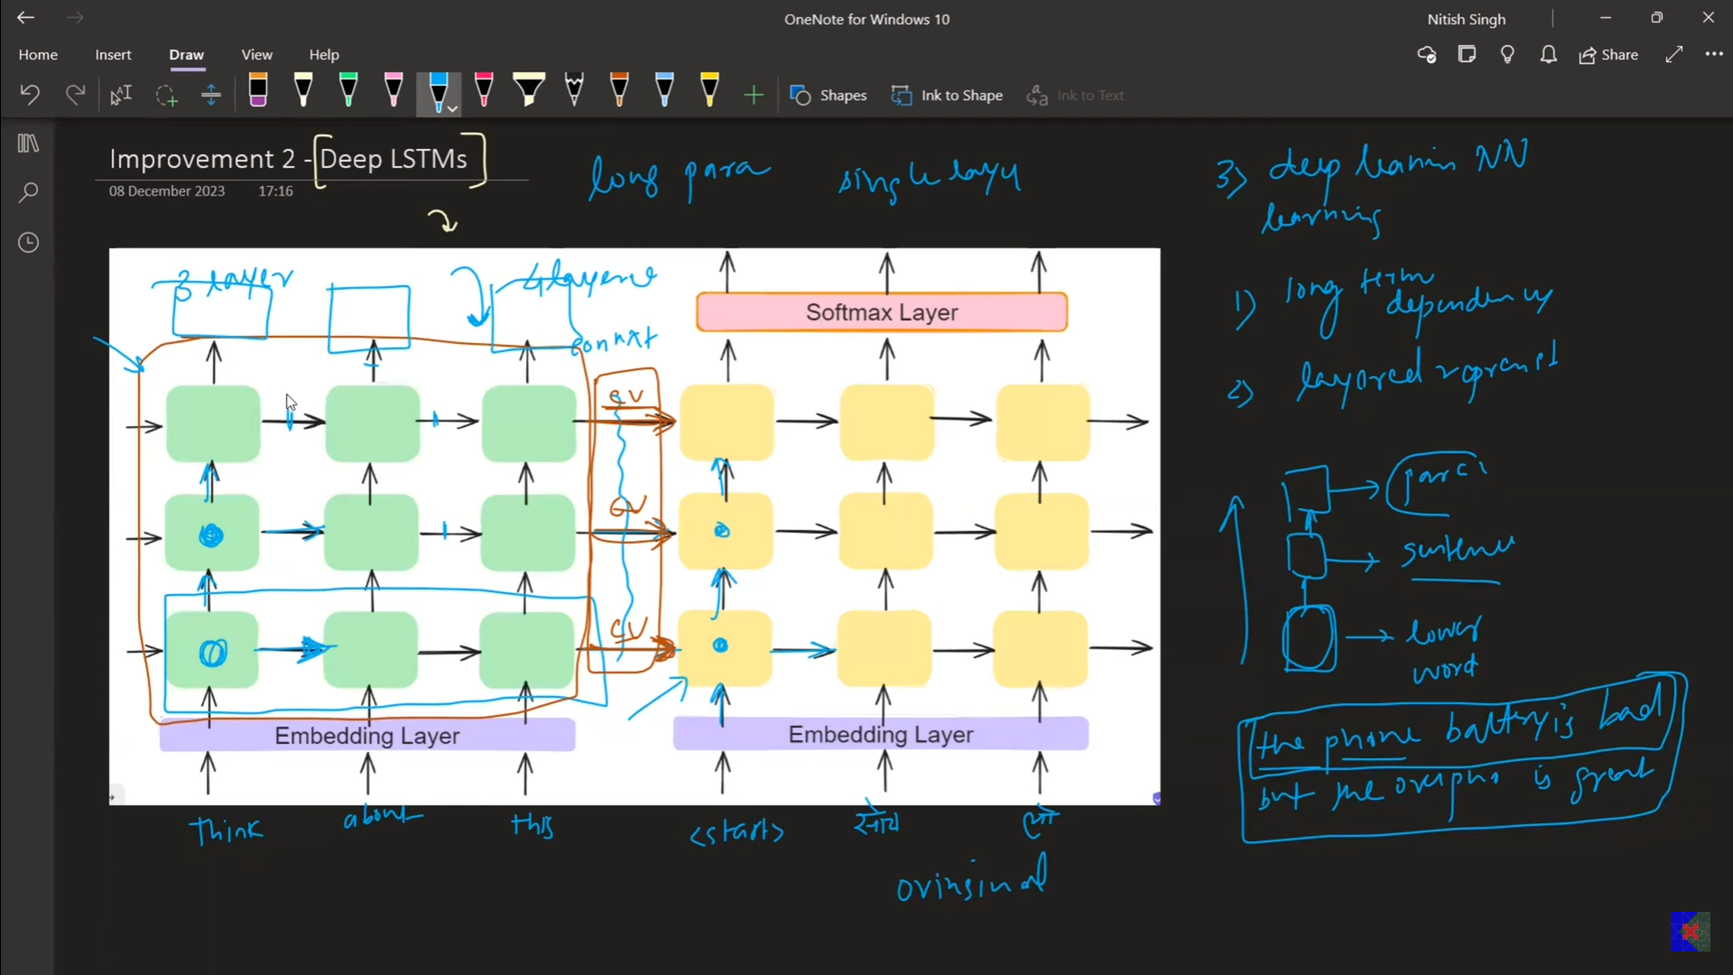
  - In the original paper, they have used 4 layer deep LSTM.

- Reverse the input
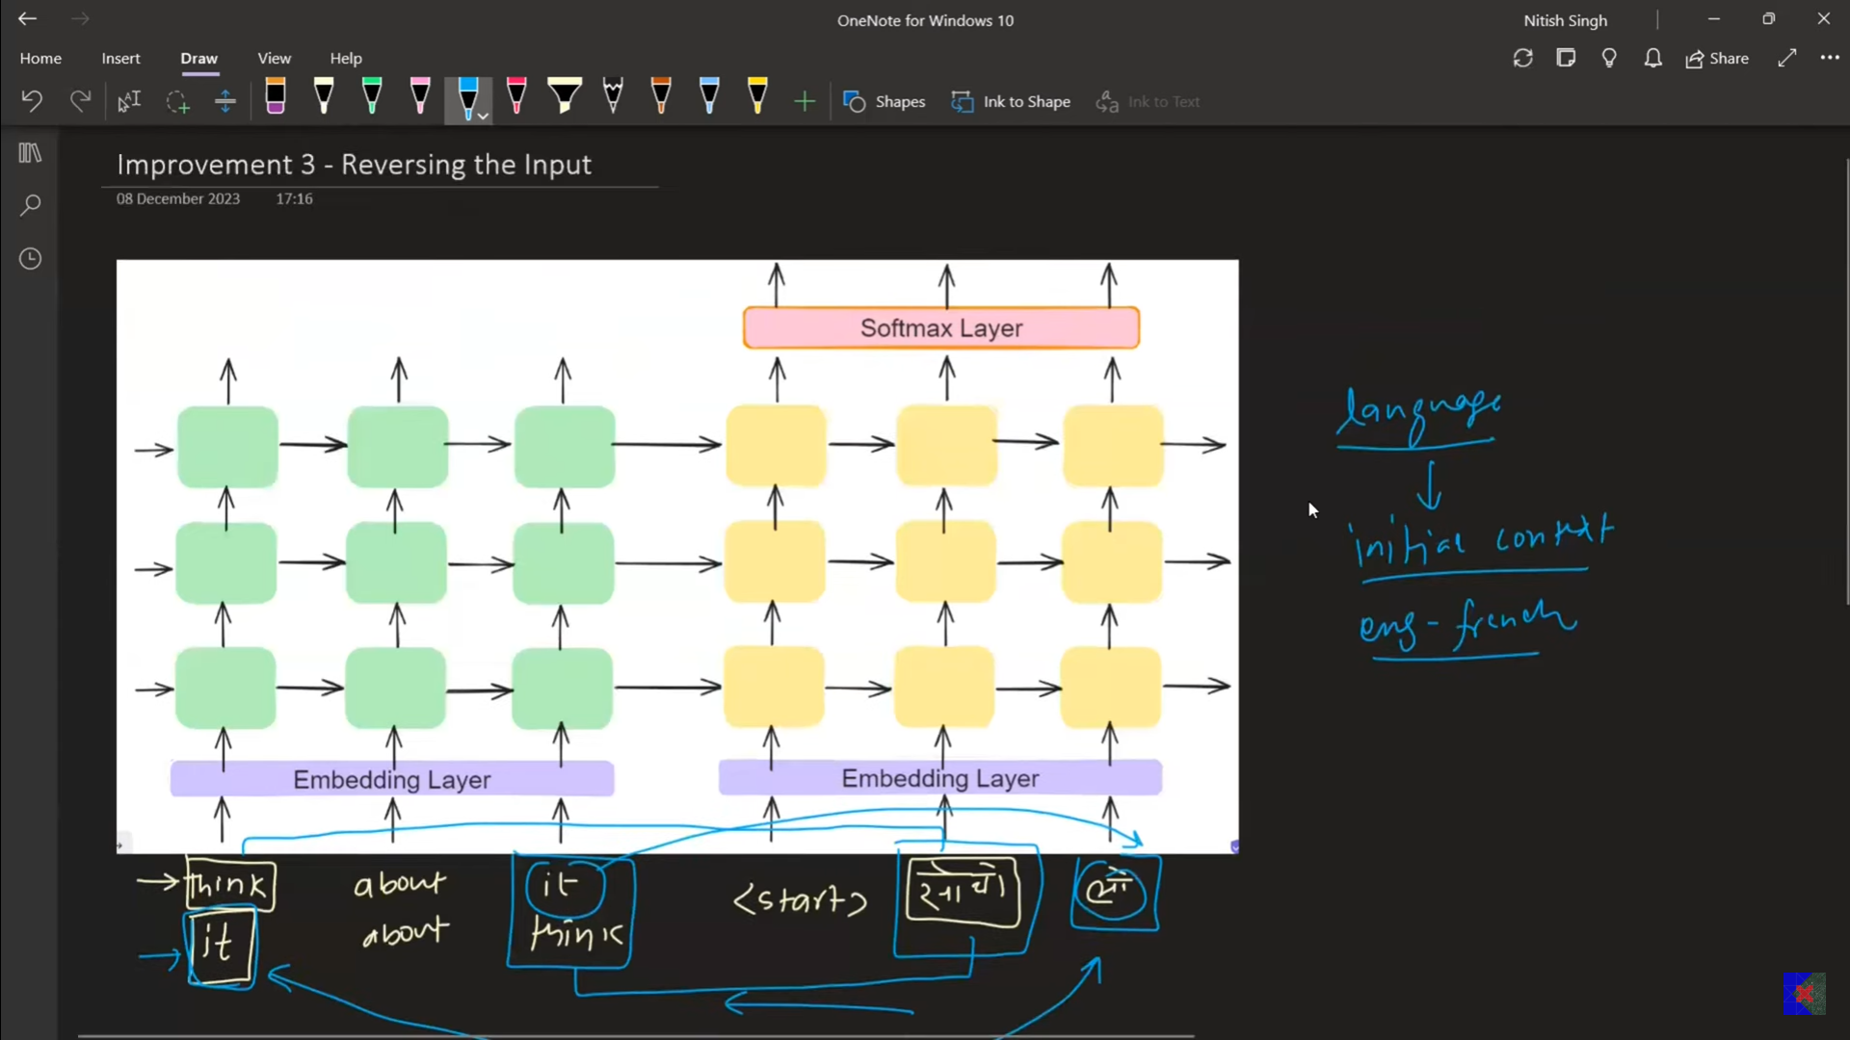
This works only when the inportance at the statring of the word in the sequence is given the larger importance. This is eorks in some contexts, not everytime it works.
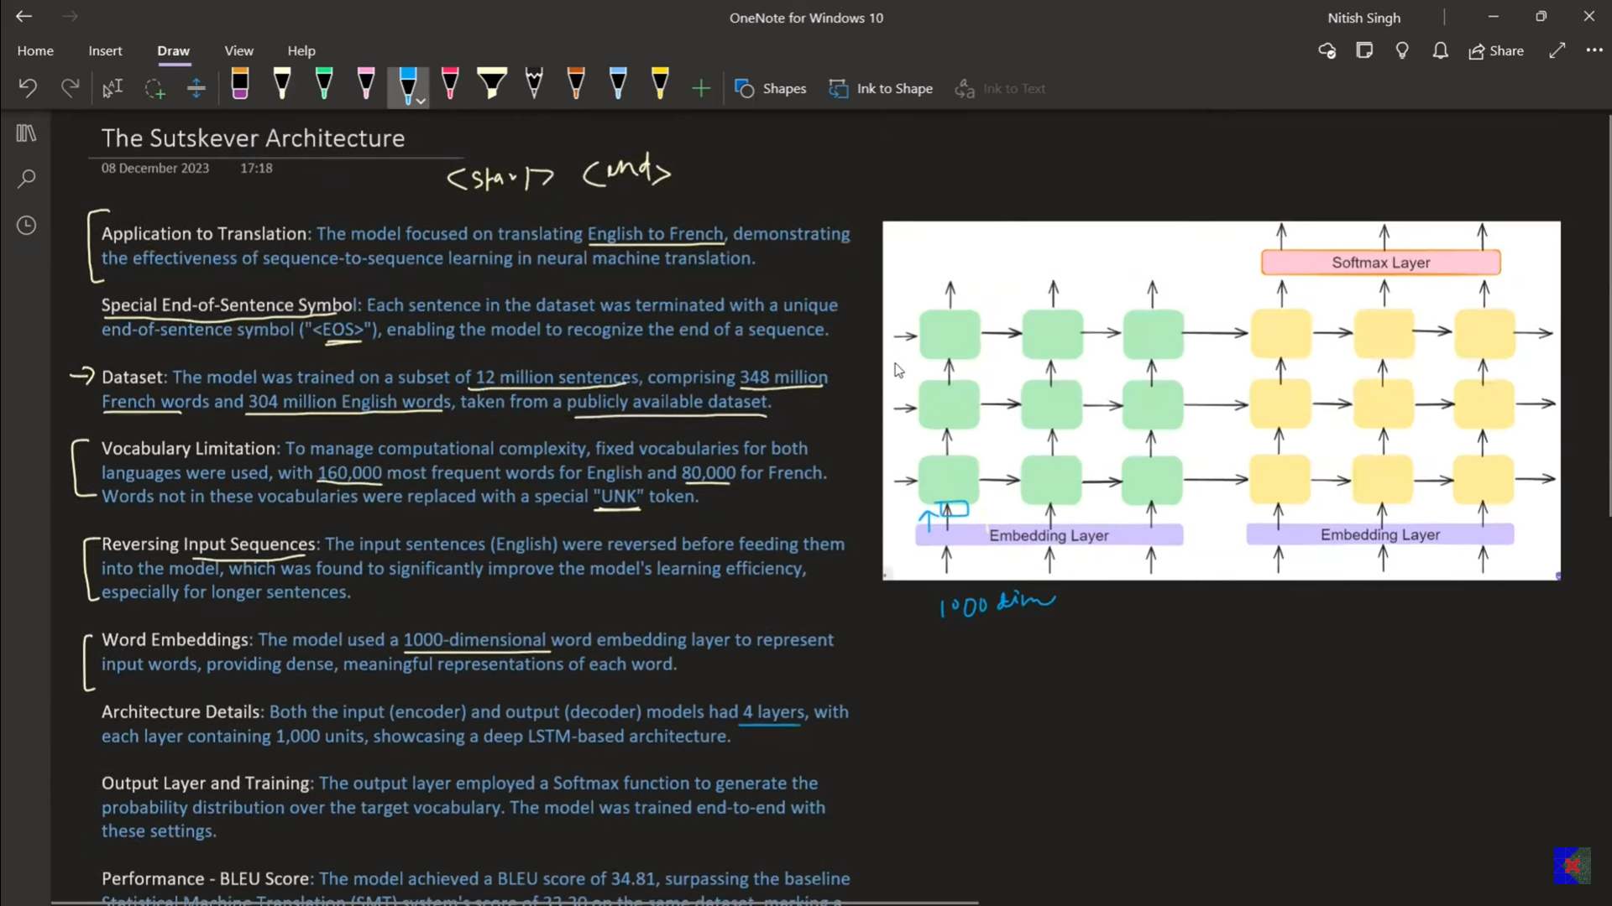
- s

